## IOT FLOOD WARNING INDICATOR WITH ARDUINO BASED SYSTEM

A Capstone Project

Presented to the Faculty Members of the

College of Computing Studies, Information and Communication Technology

ISABELA STATE UNIVERSITY

Echague, Isabela

In Partial Fulfillment of the

Academic Requirements for the Degree of

Bachelor of Science in Information Technology (BSIT) Networking and Security Track

By:

Robinson F. Lintao Jr.

Janeth B. Simangan Rowell U. Taguba

June 2022

# APPROVAL SHEET

The Capstone Project attached herein entitled: **“IOT FLOOD WARNING INDICATOR WITH ARDUINO BASED SYSTEM”** prepared and presented by **ROWELL U. TAGUBA, JANETH B. SIMANGAN,** and **ROBINSON F. LINTAO JR.** in partial fulfillment of the requirements for the degree of Bachelor of Science in Information Technology (BSIT) is hereby, endorsed.

**ADVISORY COMMITTEE**

**ROMERO DANTE C. SALUM, DIT**

Project Adviser

**PANEL COMMITTEE**

**CATLEEN M. FELICIANO, MIT DESIRAY D. NAYGA, MIT**  Content Panel Technical Panel

**DARIOS B. ALADO, DIT**

Panel Chair

Approved and accepted as partial fulfillment of the requirements for the degree Bachelor of Science in Information Technology (BSIT).

## RENALYN G. TECSON, MIT _____________________

BSIT, Program Chairperson Date

**CHRISTINE CHARMAINE G. SAN JOSE, DIT _____________________**

Dean, CCSICT Date

Recorded:

**MAYLENE E. MANUZON** **_____________________**  Registrar II Date

# DEDICATION

In this world of ours, we consider ourselves lucky because of having people who served as our inspiration in fulfilling our dreams in life. We wish to dedicate this capstone project to friends, classmates, instructors, and ISU staff who stood by us and shared knowledge and ideas to make this study possible, to our beloved family, who have been our source of inspiration and strength and who continuously provide their moral, spiritual, emotional, and financial support and above all, to our Almighty Father who gave us courage, energy, and positivity throughout the study.

Rowell U. Taguba

Janeth B. Simangan

Robinson F. Lintao Jr.

# ACKNOWLEDGEMENT

Every man writes history because he wants to record significant events that happened in life. It tells of the glorious past and great achievements, success and defeat, ideals, luck, and misfortunes as well as joy and tears. It becomes a tangible set of records whereby men could profit from this glimpse and would be able to foresee their future.

The researchers would like to express their deepest appreciation and thanks to all the people who helped in the success of this study:

To the whole **ISU – Echague Staff** including the registrar, admin staff, utility, and guards for uplifting their morale during the times that they already felt down.

To the project adviser, **Romero Dante C. Salum, DIT,** for the invaluable ideas a project adviser. And for the full trust support and guidance in pointing out errors in the project.

To our Subject adviser, **Darios B. Alado, DIT,** for straightforward comments, support and pieces of advice.

To our Technical Panel, **Desiray D. Nayga**, **MIT,** and to our Content Panel **Catleen M. Feliciano, MIT,** for their help, recommendations, and comments on the success of the study.

To our ever-trusted **Friends** and **Classmates** for all the things we have gone through, for the joys of being close to one another, for the satisfaction of the food we shared, and for the helping hands we extended to one another, thanks for every moment we were together.

To our ever-loving **Family** whom we owe our life; thank you for all the love and care, for the sacrifices on my behalf; you are my inspiration and guidance; we pray that you always be their guide and protect us, as we embark on the road we have chosen.

And above, all for the blessings we received from our **Almighty Father.**

Rowell U. Taguba Janeth B. Simangan

Robinson F. Lintao Jr.

# ABSTRACT

The IoT (Internet of Things) Flood Warning Indicator with Arduino-based System aimed to provide information to the MDRRMO and Barangay Captains about the flood approaching their respective areas. The researchers used prototyping model for a faster development of the project, and used different logical diagrams (i.e. fishbone diagram) that helped the them identify the cause and effect of the problems encountered. The flow chart diagram was used to describe the sequential order of events from the system device.

The researchers used different technologies such as Arduino Uno, SIM900A GSM module, Float Sensors to develop the system. The system was capable to detect water level of the river and send flood warning into MDRRMO and Barangay Captains in order to lessen the time in providing early flood warning to the residents of Echague, Isabela. As the system was tested, the objectives of the project was obtained by the system.

The system evaluation using ISO 25010 in terms of usability and functionality evaluated by the MDRRMO Admin and Barangay Captains results in Great Extent. This implies that the developed system is very useful in terms of giving an early flood warning from the MDRRMO and Barangay Captains from the different barangay in the river side region of Echague, Isabela.

# TABLE OF CONTENTS

**TITLE PAGE** ..................................................................................................................... **i**

**APPROVAL SHEET** **ii**

**DEDICATION** **iii**

**ACKNOWLEDGEMENT** **iv**

**ABSTRACT** **v**

**TABLE OF CONTENTS** **vi**

**LIST OF FIGURESLIST OF TABLES** ............................................................................................................ **x**  **ix**

**CHAPTER I. INTRODUCTION**  ................................................................................... **1**

1.1 Rationale of the Project .............................................................................................. 1

1.2 Project Highlights ....................................................................................................... 2

1.3 Objectives of the Project ............................................................................................ 2

1.4 Scope and Limitation of the Project ........................................................................... 2

## CHAPTER II. REVIEW OF RELATED LITERATURE AND STUDIES ............... 4

2.1 Related Literature ....................................................................................................... 4

2.1.1 Literatures ............................................................................................................. 4

2.1.2 Studies ................................................................................................................... 5

2.1.2 Synthesis ............................................................................................................ 14

2.2 Concept of the Study (IPO) ...................................................................................... 15

**CHAPTER III. METHODOLOGY**  ............................................................................. **16**

3.1 Requirement Analysis .............................................................................................. 16

3.1.1. Fishbone Diagram .............................................................................................. 16

3.1.2. Gantt Chart ......................................................................................................... 17

3.2. Technical Background ............................................................................................. 18

3.3. Data, Software, and Hardware Specification .......................................................... 18

3.3.1 Data ..................................................................................................................... 18

3.3.2. Software ............................................................................................................. 18

3.3.3. Hardware ............................................................................................................ 19

3.4. Flow Chart Diagram ................................................................................................ 20

3.5. System Design ......................................................................................................... 21

3.5.1. System Development Methodology ................................................................... 21

3.5.2 Development and Testing ................................................................................... 21

3.5.3 Data Gathering Procedure ................................................................................... 22

3.5.4. Data Analysis ..................................................................................................... 22

3.5.5. Population of Study ............................................................................................ 23

3.5.6. Cost-Benefit Analysis ........................................................................................ 23

3.5.7. Risk Analysis ..................................................................................................... 25

3.6. System Testing ........................................................................................................ 25

3.7 Implementation Plan ................................................................................................. 26

**CHAPTER IV. RESULTS AND DISCUSSION**  ......................................................... **27**

4.1. Designed and Development of IoT Flood Warning Indicator with Arduino-based

System ............................................................................................................................ 27

4.1.1. Developed System Device ................................................................................. 27

4.1.2. Design of the Developed System Device ........................................................... 28

4.2 Test System Functionalities ...................................................................................... 29

4.2.1. Short Message Service (SMS) Yellow Warning................................................ 29 4.2.2. Short Message Service (SMS) Orange Warning................................................ 30

4.2.3. Short Message Service (SMS) Red Warning ..................................................... 31

4.2.4. Flood Warning Indicator Sensors ...................................................................... 32

4.3 Evaluation Result (ISP 25010) ................................................................................. 33

## CHAPTER V. SUMMARY, CONCLUSION, AND RECOMMENDATIONS ......... 36

5.1 Summary................................................................................................................... 36

5.2 Conclusion ................................................................................................................ 37

5.3 Recommendation ...................................................................................................... 38

**BIBLIOGRAPHY** ............................................................................................................ 39

**APPENDICES** ................................................................................................................ 43

1. Relevant Source Code Appendix ............................................................................. 45
2. Sample Input/Output/Report Appendix ................................................................... 52

1. User’s Guide Appendix ........................................................................................... 56
2. Other Relevant Documents Appendix ..................................................................... 62 E: Grammarian Certificate Appendix ............................................................................ 65

F. Gallery Appendix ..................................................................................................... 67

G: Curriculum Vitae ...................................................................................................... 72

**GLOSSARY**  ................................................................................................................... 75 **LIST OF FIGURES**

Figure 1. Input- Process-Output (IPO) ........................................................................... 15

Figure 2. Fishbone Diagram ........................................................................................... 16

Figure 3. Technical Background .................................................................................... 18

Figure 4. Flow Chart of the System................................................................................ 20

Figure 5. Prototyping Model .......................................................................................... 21

Figure 6. Developed System Device .............................................................................. 27

Figure 7. System Design................................................................................................. 28

Figure 8. Yellow Flood Warning SMS Content ............................................................. 29

Figure 9. Orange Flood Warning SMS Content ............................................................. 30

Figure 10. Red Flood Warning SMS Content ................................................................ 31

Figure 11. Flood Warning Indicator Sensors ................................................................. 32

**LIST OF TABLES**

Table 1. Gantt Chart of the Project .................................................................................17

Table 2. Hardware Specification ....................................................................................19

Table 3. Likert Scale .......................................................................................................22

Table 4. Respondents......................................................................................................23

Table 5. Hardware Cost ..................................................................................................23

Table 6. Software Cost ...................................................................................................24

Table 7. Development Cost ............................................................................................24

Table 8. Risk Control .....................................................................................................25

Table 9. Implementation Plan.........................................................................................26

Table 10. Functionality ...................................................................................................33

Table 11. Usability .........................................................................................................34

Table 12. Evaluation Summary ......................................................................................35 2

**CHAPTER 1**

**INTRODUCTION**

This chapter covers the rationale of the study, project highlights, objectives of the study, and scope and delimitations for the development of the project.

## 1.1 Rationale of the Study

The Internet of Things (IoT) Flood Warning Indicator with Arduino-based System is used to monitor the water level and detect the possible flooding of different areas in any place that is experiencing floods. The goal of this study is to ensure the safety of lives by informing them of possible occurrences of floods in their areas, especially in the areas near the Annafunan Bridge in Echague, Isabela. The researchers of this capstone project focused on monitoring the water level in Annafunan Bridge for potential flooding in the area.

Most of the barangays in Echague, Isabela experienced flooding. Thus, the researchers developed a system that is very beneficial to the people living in Annafunan especially that their safety is the top priority. The process of using this system is that, when a water sensor has been activated and detected that there was possible flooding, the message will be directly sent to the microcontroller. Then, the microcontroller will send the warning signal to the admin through SMS using the GSM module that is connected to it so that the admin will be informed on the occurrences of flood in Annafunan Bridge. This project provided information about the flood warning near the Annafunan Bridge.

The Internet of Things (IoT) Flood Warning Indicator with an Arduino Based System will be used as signal for early evacuation of people living near the areas before the flood occurs. Using this system, ensures the safety of lives and reduce the likelihood of deaths of respondents, damage of properties, crops and death of animals due to 3

drowning in floodwaters in their areas. IT respondents know that one of their jobs is to secure data and information of one’s person or a user, but it is even more important to secure first the lives of users who use the developed products and technologies. The information and data of users need to be secured and so are the lives of people living around it, but their lives are not. But how can life be secured of it’s already lost? That is why this system has been developed, in order to secure the lives of those people live near the river.

## 1.2 Project Highlights

The following are the highlights of the project:

* Send Flood Warning Through Short Message Service (SMS)
  + The system is capable to send an early warning through SMS to the MDRRMO and Barangay Captains.
* FloodWarning Indicator
  + The system could identify the level of water at Annafunan river from yellow which is sending alert, orange for preparation, the red for evacuation.

## 1.3 Objectives of the Study

This project Internet of Things (IoT) Flood Warning Indicator with an Arduino Based System aimed to provide a system that could notify MDRRMO and Barangay Captains about the water level. Specifically, the researchers aimed to:

1.3.1. Test the following system functionalities:

1.3.1.1 Short Message Service (SMS)

1.3.1.1 Flood Warning Notification

1.3.2. Evaluate the System in terms of ISO 25010 Product Quality Standard

1.3.2.1 Usability

1.3.2.2 Functionality

## 1.4 Scope and Delimitations

4

The project is implemented in the Municipality of Echague, especially in the riverside region of the municipality near Annafunan Bridge which consists of the following barangays: Dammang East, Dammang West, Malitao, Rumang-ay, Busilelao, Sta Cruz, San Salvador, Nilumisu, San Felipe, Bacradal, Babaran, San Carlos, and Caniguing, that experience flooding during typhoon or heavy rainfall.

The system supports an SMS notification to inform the admin about the flood level and its condition, whether it is increasing or decreasing from time to time. The SMS also contains directions and strategies on how the respondents should react when there is a possible flood approaching their area. The MDRRMO is the one who will add or update the cellphone numbers from the code then upload it into the system device. Researchers used the Arduino Uno IDE which supports a C++ programming language to program the system.

The user of the system is the MDRRMO Administrator who manages the system device and receive flood warning through SMS. The Barangay Captains from the different barangays affected by the flood will also receive SMS about the Flood Warning. The connection of the device was through network connection using GSM Module Sim900A. The SMS will only be sent in MDRRMO admin and to the 13 Barangay Captains who will be affected by the flood in Echague, Isabela.

5

**CHAPTER II**

**LITERATURE REVIEW**

This chapter covers the review of related literature and studies the researchers used as the basis for conceptualizing this research proje. The following are the related literatures and studies:

## 2.1 Related Literature

### 2.1.1 Literatures

Floods are the most destructive and dangerous natural calamity in this world. In the event of a flood, it can demolish the community and can affect many lives in different ways. It is very necessary to design a flood control device as a mechanism to reduce floods.

The world’s weather is changing rapidly due to effect from mankind activities such as pollutions, trees cutting, vehicle gas emission etc. Floods are the most usual damaging natural disaster that cause significant harm to life, property, and economy. Scientists estimate by 2030, if sea level rises by 4-Inches, it could potentially cause the severe flooding in many regions of the globe. This project implies a flood warning structure that can detect the water level and measure the speed of the increase in water level. To give the nearby respondents an earlier notification to evacuate before the water rises to the dangerously high level, the measured result is sent as an alert on a mobile through Short Message Service (SMS). This prototype is designed on a IOT platform, where data from the sensor is stored at the mini-processor and alert is generated & sent as SMS to a smartphone. As the definition of IOT, if we take a sensor as a process element of IOT which make it possible to communicate its live condition and post it live on Internet, then our concept is very similar to achieve within the concept of IOT. Nevertheless, the real reason of this idea is to achieve an early flood warning system (Jadvah, et. al, 2020).

The implementation of flood alert systems near any major water area or body of water provides critical information that can protect property and save lives. This researchers is to inform the respondents about the upcoming flood by making use of the concept of Internet of Things (Sayyad, et. al, 2020).

6

(Rismayana, et. al, 2018) added high water flooding will not be a problem when it does not cause loss of property, human life, and does not soak the settlement of citizens for a long time. However, when overflow of large volumes of water occurs for a long time and often this can disrupt the activities of the respondents living in the area. This is a problem, this flood disaster is not only disrupting the activities of the respondents, even the effects further impact to social and economic development, even dangerous of human life. This flood disaster could not be eliminated, but the problems that arise from this flood could be reduced by the system that capable of providing an early warning flood.

Today, many flood-prone countries, including the tropical nation of Indonesia that suffers from monsoonal rainfall, are exploring IoT sensors to gather intelligence for issuing early warnings and annual monsoonal rainfall, are exploring IoT sensors to gather intelligence for issuing early warnings evacuate orders to respondents at risk of major floods. The IoT has gained increased popularity in the and evacuate orders to respondents at risk of major floods [13]. The IoT has gained increased popularity last decade, particularly within the context of smart city applications such as real-time monitoring of in the last decade (Arshad, et. al, 2019).

Flooding warning system based on Internet of Thing is very interesting, because this technology we can prevent many losses of property or life and property. hence research represented an effective system detection of flooding with smart phone application and internet to speed up flooding information to the respondents. This research also proved that water characteristic can become an important parameter for flooding warning information. Although the quantity of sensor was influenced by the accurate of detection (Yuliandoko, et. al, 2018)

### 2.1.2 Studies

Flood Warning Indicator is an IoT (Internet of Things) and Arduino-based System that needs by the respondents, especially the respondents near the rivers or the areas that always encounter floods.

Flooding is a great treat towards mankind as it is also considered one of the most devastating natural disasters in the world. It is not any abnormal scenario worldwide, since 7

it results in great damages to agriculture land, residential area and even cities with high cost in lives and towards the economy of the country. The government has to spend tons of money in flood mitigation plans in afford to help the victims and also to reduce the number in the long run. Most of the flood mitigating plans has high cost and only can be implemented base on priority. Baring the cost and safety measures, this paper highlights the Flood Observatory System (FOS) as a warning and alert system to efficiently monitor the critical flood prone areas in real time basis. FOS can be deployed in flood prone areas in afford to create a well-used standard for remote flood observation systems. The ability to receive real time information on flood level empowers both government and private organizations to react to imminent danger in an effective manner. With the real time flood information, allows public safety organizations and other emergency managers to effectively plan their resource deployment within the limited time of alert. Warning as flood rises could be used to save lives and properties in many ways can help such organization and government to spend sufficient amount of money in restoration process. The simple and practicality of a system should be useful in all means towards mankind (Subramaniam, et. al, 2010).

The use of IoT in urban environments allows the emergence of Smart Cities, where urban information, transit, climate and time, water and waste, health, government services, energy and transportation are interconnected with the population and authorities in general. The purpose of these cities is to adapt the organization and coexistence of the population through the variations and availability of information transmitted by the urban environment in real time. Warning systems are often entrusted with issuing warnings at risk of tragedy. These systems generally consist primarily of a hydrological model, supported by meteorological data obtained by monitoring, visual observation and weather forecasting. Natural phenomena, which affect regions and negatively affect local development, causing financial losses, can be monitored using different devices, such as sensors, satellites and seismograph. the system starts to monitor the water level of the river using a sonar (ultrasonic sensor HC-SR04). It sends the extracted data to a microcontroller. The microcontroller processes the data, and subsequently, periodically performs an average of the monitored levels in order to minimize errors due to current disturbances. The obtained 8

results are stored in the cloud for the purpose of being applied in research and study of the place. Each light color corresponds to a situation, for this project was defined:

**Green:** corresponds the level of the river is stable and normalized.

**Yellow:** it affirms that the level of the river is above normal, in the entente, without crossing its bed, thus being characterized a situation of flood.

**Red:** denotes that the location is at risk as a flood.

When the yellow comes on, indicating a flood situation, the flood warning system sends a SMS to an emergency central with a flooded area identifier and information on a forecast of the weather conditions that may or may not occur. When the red is on, signaling flood, the same GSM module, makes a telephone call to an emergency center informing the flood in the place. The color, serve as signaling the situation of the monitored river to the population, this way the population, can take measures in a timely manner in order to minimize further social damage. The notification by SMS and telephone call, serve to notify the public authorities in order to intervene in the critical region and may accentuate evacuation of the population of the region (Souza, et. al, 2017).

The technology used to detect floods is now more accurate than the devices of the last decades. Unfortunately, an early warning system still showing some lacks of significant and difficult to alert all the respondents in the area. Therefore, multiple of factors that need to be considered to develop a wireless sensor node system in order to avoid any failure occurred. The system should be low-cost, multifunctional, low-power and wireless sensor nodes of small size that work together to sense the environment, process the data and communicate wirelessly over a short distance. Sensor is a device that measures and converts a physical quantity into a signal that an observer or an instrument can read. Usually, the sensors are used to monitor physical or environmental conditions, such as sound, pressure, pollutants, water level or motion at areas of interest. Accurate data from the sensors are important for many kinds of purposes including forecasting on flood event and for the future improvement of the system. Study about Internet of Things (IoT) technology has gain popularity and becoming important for solving more problem in various disciplines, for example water monitoring system, flood monitoring and weather station application. To reduce the effect of the disaster, a flood warning and monitoring are needed to give an early warning to the victims at a particular place with high prone to flood. 9

By implementing the Internet of Thing technology into the system, it could help the victim to get an accurate status of flood in real-time condition (Mohd Sabre, et. al, 2019).

Flood is one of the natural disasters that cannot be avoided. It happens too fast and affected so many lives and properties. Before this, most of the existing system that has been developed are only focus on certain areas. Other than that, majority of the public cannot monitor and have no idea when the flood going to be happened since they do not have any information and data about the weather condition. By having Smart IoT Flood Monitoring System, this will solve all the drawbacks of the existing system (SB Zahir, 2019).

Early flood warning systems according to Grust (2008) are essential for the protection of the population against flood hazards as it allows respondents to get prepared. However, early flood warning systems will not prevent flooding. Perez et.al (2007), also said that it is a community-based flood warning system that can be used for disaster mitigation and disaster preparedness of the community because it provides an early flood monitoring and warning services. Based on studies conducted, flood warnings should be accurate, informative, timely, targeted to appropriate audiences, trustworthy and reliable to enhance flood forecasting and warnings (Labo, et. al, 2016).

This research introduces an IoT-based system that warns authorities of an impending flood. In rivers and drains, the water flow rate is measured using an IR sensor, and the water level is monitored using an Ultrasonic sensor. These sensors values are communicated over Wi-Fi to the main controller, which checks them and sends an alarm (buzzer) and an alert Short Message Service (SMS) to the mobile. The map of water levels and flow rates can be seen on a website. The website also includes weather forecast information acquired from the internet (Sheshu, et. al, 2018).

The growing number of flood-related deaths and financial losses experienced each year around the world calls for better flood response. Surprisingly, a succession of research initiatives over the last decade have explored how camera images and wireless sensor data from Internet-of-Things (IoT) networks can improve flood management. This study provides a comprehensive assessment of the literature on IoTbased sensors and computer vision applications for flood monitoring and mapping. The work makes a contribution by emphasizing the most often used computer vision algorithms and IoT sensor approaches in the literature for real-time flood monitoring, 10

flood modeling, mapping, and early warning systems, including water level estimation (Arshad, et. al, 2019).

Flood disasters are one of the most common natural disasters all around the world. Flood management is an important aspect of the governance of flood-prone areas or countries. Information Technology (IT) has been increasingly used to help in flood management in recent years. In many regions of the world, for example, using sensors to measure hydrological data such as water level and then relaying that data over the network has become commonplace. The same can be said for the collection and transmission of flood-related geological and meteorological data. This infrastructure, when combined, constitutes the Internet of Things (IoT) (Ghapar, et. al, 2018).

Floods are the world's most destructive natural calamity. Heavy floods have the potential to damage communities and kill many respondents. The government plans to spend billions of dollars to repair the damage. The development of a flood control system as a technique to reduce flood risk is critical. It is critical to provide immediate input on the arrival of a flood in order to inform residents to take immediate action, such as evacuating to a safer and higher location (Shah, et. al, 2018).

Floods and earthquakes are two of the world's most damaging natural calamities. Such natural disasters have negative consequences for the environment, human lives, and the economy of the country. The death rate of humans and animals has decreased as a result of such natural calamities. As a result, a flood and earthquake detection system should be monitored and observed. The suggested system, which is based on IoT technology, provides real-time flood and earthquake analysis, allowing authorities to monitor flood and earthquake-affected areas. This study focuses on the Flood and Earthquake Observatory System as a warning and alert system for efficiently monitoring flood-prone and earthquake-prone areas in real time while keeping costs low (Babu, et. al, 2019).

In Indonesia, floods are one of the most common natural disasters. Floods have claimed the lives of numerous respondents. Flood disasters occur as a result of humancaused environmental imbalances, such as forest degradation and exploitation that knows no bounds. The flood information system in the middle of society is still done 11

the old-fashioned way, with associated parties such as the Regional Disaster Management Agency (BPBD) and the police communicating verbally. A delivery system that has been implemented by the community using community communication methods is nevertheless regarded to have time and information limitations (Satria, et. al, 2018).

Flooding is a natural occurrence in which both living and non-living organisms in the environment experience varying losses. Humans cannot completely prevent floods; nevertheless, the only thing humans can do is establish appropriate methods to anticipate floods and take appropriate precautions to warn respondents when they occur. Many technology exist to forecast and avoid disasters. Floods are caused by a variety of natural calamities. Heavy rainfall and tropical cyclones are two of them. These floods entail both material and human losses. The primary motivation for the creation of a flood alarm system is to provide early warning of a flood so that human losses can be minimized by evacuating respondents to safe locations and valuable property can be protected (Jayashree, et. al, 2017).

Because no one knows when a storm will come these days, those living near flooded areas should be prepared. As a result, we created this system to notify individuals of the impending flood via notification and alarm messages. We will use some sensors for this purpose, which was useful in providing flood information. We will also provide all safe locations around the user's location where they can migrate. We always use a map to locate a safe area. Organizations, communities, and individuals interested in creating and operating flood monitoring and warning systems can use this system to get started (Patil, et. al, 2019).

Respondents are less aware of floods since there is no early warning system in place when they occur. Researchers created a flood detection system that monitors water levels automatically and sends out early flood warnings in this study. This water level monitoring system uses a nodemcu esp8266 with ultrasonic sensors and IOT to deliver real-time data to determine the water level created at specific levels. This system is connected to the internet and displays real-time water level data on the Thingspeak platform, as well as being integrated with the Telegram app as a flood early warning system (Diriyana, at. al, 2019).

12

Floods are unpredictable natural calamities that might strike at any time. Many individuals died, and property was lost. This is supported by recent statistics, which shows that from November 2016 to November 2017, Indonesia experienced 713 flood disasters, with 140 individuals killed or missing [1]. Consider the frequent floods in the Baleendah region of Bandung District, West Java, where two Bandung regency citizens were killed.

Floods killed one person and swept away three others [2]. Building a flood early warning detecting system (FEWDS) that can be put on a water level monitoring system is one of the risk mitigation methods that can be recommended to minimize the catastrophic/detrimental impacts of floods (Simatupang, et. al, 2019).

Natural disasters are a combination of natural hazards and vulnerabilities. Natural as well as human-caused disasters cause infrastructure damage, misery, financial losses, injuries, and a large death toll each year. Researchers all across the world are striving to come up with a unique way to collect, store, and analyze Big Data (BD) in order to anticipate flood-related outcomes. To tackle these challenges, this study proposes ideas and methods for flood disaster detection based on IoT, BD, and convolutional deep neural network (CDNN) (Anbarasan, et. al, 2020).

The number of natural disasters that occur each year is increasing at an alarming rate, raising serious concerns for human life and economic survival. The rainfall pattern has also been disrupted, resulting in an unprecedented number of floods in recent years.

Flood disasters are costly to the economy and to respondent’s lives. Floods affect millions of respondents every year in Asia alone. This has drawn the government's attention to the need to develop a flood forecasting method in order to prevent floodrelated deaths. A flood mitigation method incorporating a tiny flow, water level sensor, and pressure gauge was assessed in this study. A 2-class neural network is utilized to predict flood status using data from the two sensors (Abdullahi, et. al, 2019).

Flood is an unavoidable natural hazard. It happens too quickly and affects a large number of respondents and buildings. Prior to this, most current systems only focused on a few topics. Aside from that, because they lack information and data regarding weather conditions, the bulk of the respondents is unable to monitor and predict when a flood would occur. The Smart IoT Flood Monitoring System will 13

eliminate all of the shortcomings of the current system. The proposed approach is appropriate for both urban and rural settings. Furthermore, if the general population has internet access, they may watch what is going on and predict if a flood will occur at the web server (Zahir, et. al, 2019).

During the past monsoon season, catastrophic flooding occurred in the Indian state of Kerala, which resulted in significant damage and was unprecedented in the last century. Nearly 373 respondents have perished in the last two weeks, and nearly 83 percent of the state's dams have been opened to prevent additional deaths. Flood risk should thus be monitored on a regular basis. As a result, a wireless sensor network (fWSN)-based early warning system is necessary to save the lives of individuals living in dangerous places. A Wireless Sensor Networks system has been designed in this study, and it consists of sensor hubs that are sent to certain surge and helpless locations for real-time surge checking and discovery. Because data can be collected quickly and efficiently, Wireless Sensor Networks (WSN) can be used for a variety of other realtime tasks. The sensor node is made up of sensors with minimal processing and communication capabilities, such as temperature, ultrasonic, and rain sensors. The detected data from the sensors is sent to the microprocessor for further processing (Subashini, et. al, 2021).

It makes a machine as clever as a human by giving it all of the possibilities to choose from. Researchers have attempted to build a method for feeding intelligence to software that can make decisions regarding potential flood situations. IoT-based development for environmental parameter detection is popular these days, but there is no way to supply intelligence to the system so that it can use the acquired data. This research presented a prototype of an Expert system to predict flood risk in areas where an IoT-based sensing mechanism has been placed to collect data on water level and rainfall. This expert system was useful in determining flood risk for a big population, particularly in metropolitan regions (Kumar, et. al, 2020).

Every year, natural disasters cause massive damage and losses, both economically and in terms of human lives. The development of technologies to forecast disasters and create and disseminate timely warnings is critical. Technology such as Internet of Things solutions have recently been combined into alert systems to give an 14

effective technique of gathering environmental data and producing notifications. This paper examines the literature on Internet of Things (IoT) solutions for early warning of natural disasters such as floods, earthquakes, tsunamis, and landslides. The purpose of this study is to describe the most widely used IoT designs, establish the limitations and requirements of an Early Warning system, and systematically determine which solutions are more commonly utilized in the four use cases analyzed (Esposito, et. al, 2022).

Floods have had severe effects in the past, causing millions of dollars in infrastructure to be destroyed. Even after so much research, there is still no global ubiquitous system that can collect, store, evaluate, and generate flood prediction findings from big data. With the confluence of big data and HPC, a social collaborative Internet of Things (IoT) based smart flood monitoring and forecasting architecture is described in this work. It divides geographic areas into hexagonal webs to facilitate the installation of energy-efficient IoT devices. These IoT devices sense all necessary flood producing and flood preventive qualities, which are then computed utilizing big data and HPC computing. For attribute reduction, Singular Value Decomposition (SVD) is used (Sood, et. al, 2018).

In order to lessen the hazards of flooding, an early flood detection and monitoring system using the Internet of Things and the Global Positioning System is proposed. The goal of this project is to deliver current water level information in a drain. The system will send a warning signal to customers when the water level reaches a specific level, showing three kinds of water level: safe, warning, and critical. This system includes an ultrasonic sensor that detects the current water level while also allowing users to view the duration of the water level from their phone, allowing them to be more aware of when flooding is likely to occur (Hadi, et. al, 2020).

The Internet of Things (IoT) is a technology that allows you to connect anything to the Internet. IoT is the newest technology that is rapidly gaining popularity. New goods, such as disaster monitoring, are made possible by this technology. Flood disaster is a major problem in Malaysia because floods occur every year. We can use this technology to monitor activities that respondents are unable to perform in 24 hours and provide real-time feedback to users. We present an IoT approach termed as flood 15

warnings system using Android application in this research. This device will keep track of any potential drainage flooding that may occur and broadcast the information in real time to everyone in the area (Napiah, et. al, 2017).

Flood prediction, flood monitoring, and flood detection have all used the Internet of Things (IoT). Although IoT technologies cannot prevent flood disasters from occurring, they are an extremely useful tool for transmitting disaster readiness data. Artificial neural networks have made strides in flood prediction (ANN). Despite advances in flood prediction systems, there has been less emphasis on using edge computing to increase the efficiency and reliability of such systems. In this study, we demonstrate a system that leverages IoT and ANN to anticipate short-term floods, with the prediction computation taking place on a low-power edge device. The system uses temporal correlation information to analyze real-time rainfall and water level sensor data (Samikwa, et. al, 2020).

Because we live in the Information Age, everyone and everything must be connected to the internet. The Internet of Things (IoT) is a technology that is bringing us closer to this aim. Our concept includes a smart water monitoring system that serves as a tiny prototype for flood detection and prevention. This document outlines how all of the components in our project work and how they work together. The sensors detect their surroundings and provide real-time data to the cloud (Firebase cloud), which users may view and access via their mobile platform. After the water level reaches a certain height, the model issues an alert (Roy, et. al, 2020).

### 2.1.3 Synthesis of the study

The researchers discovered the utility of related literatures as a major premise for conducting the investigation with the help of linked literatures, as well as the significance of relevant studies and research approaches in terms of carefully defining the agency's process flow and needs, and the effective system development planning to meet the project's objectives.

16

## 2.2 Concept of the Study (IPO) IoT Flood Warning Indicator with Arduino based System



**Input**



**Process**



**Output**



•

Cellphone

number

•

Flood

warning

sensor

signal



•

Initial Requirement

o

Design

o

Prototyping

o

Costumer

Evaluation

▪

Costumer

o

Review and

Update

•

Development

•

Test

•

Maintain



•

Flood warning

SMS

notification to

MDRRMO and

barangay

captains



F

ee

dbac

k

*Figure 1. Input-Process-Output (IPO)*

Figure 1 shows the Input which contains cellphone number and flood warning message content, Process contains prototype process which indicate initial requirement, development, test, and maintain; and the Output of the System which contains flood warning through SMS notification.

**CHAPTER III**

**METHODOLOGY**

The researchers used the prototyping model for the faster development of the system. The different phases such as, requirements gathering, quick design, built prototype, customer evaluation, review and updating, and satisfaction of the customer with the design go to the development of the system, test, and maintenance.

## 3.1 Requirement Analysis

### 3.1.1 Fishbone Diagram

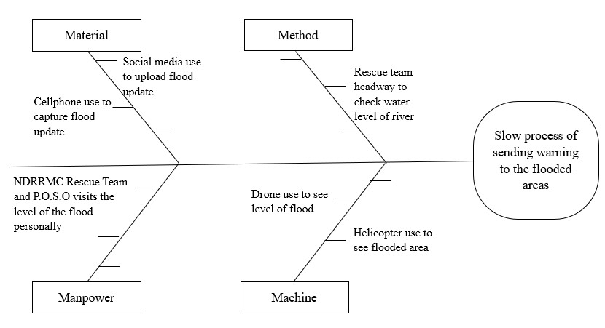

MDR

R

MO

*Figure 2. Fishbone Diagram*

Figure 2 shows the problem which is the overflowing river in Annafunan bridge, Echague, Isabela , and the late flood warning, in barangays near the Annafunan bridge which is the riverside region of Echague. It is also shows the different effects of the problem presented by the 4M’s method on material, manpower, and machines.

## 3.1 Gantt Chart

Gantt chart below was used as a guide by the researchers to determine whether the researchers meet the project deadline.

Table 1. Gantt Chart of the Project

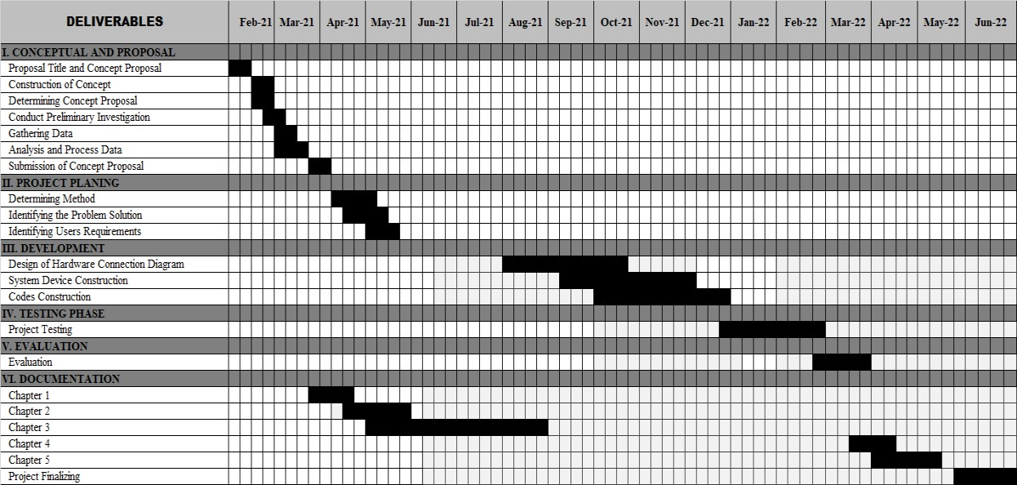

Table 1. Unveiled the Gantt chart which consists of deliverables and duration of the system, the deliverable contained a conceptual proposal, project planning, development, testing phase, evaluation, and documentation.

## 3.2 Technical Background

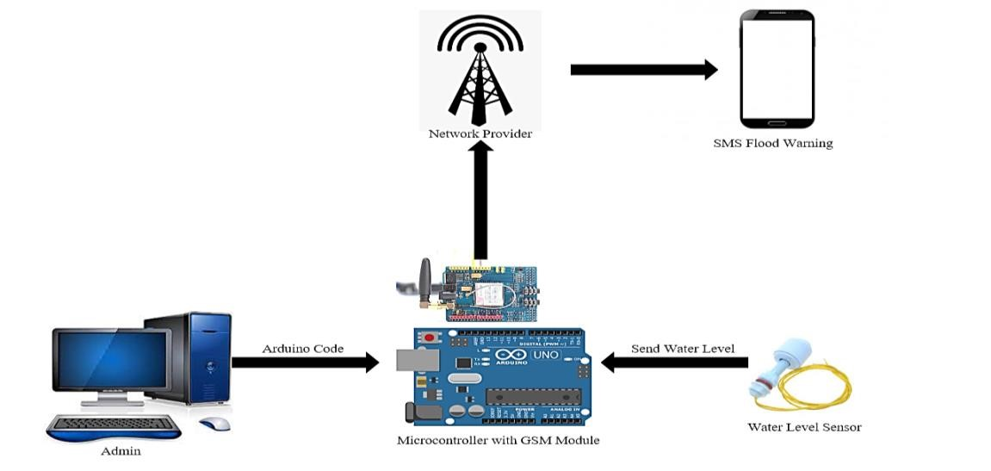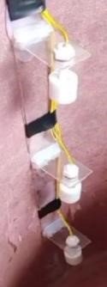

*Figure 3. Technical Background*

Figure 3 shows the different components of the project. The content from the SMS will provideed by the admin inserted into the Microcontroller with GSM Module and the Float Sensor will provide data which is the water level and the all the data will pass through network provider and the information will be sent to the user’s smart phone thru SMS.

## 3.3 Data, Software, and Hardware Specification

### 3.3.1 Data

**Float Sensor:** it is used to detect incoming flood and sends detected flood data to the Arduino.

**Flood Warning Signal:** is used to warn the MDRRMO and barangay captain about the flood incoming their areas.

**Short Message Service (SMS):** it is used to inform MDRRMO and Barangay Captains about the level of the flood.

**Contact Number:** data needed in order to receive the flood warning message.

### 3.3.2 Software

**Arduino IDE -** It is connected to the Arduino and Genuino hardware to upload programs and communicate with them. The Arduino IDE is the one that is used for coding the microcontroller so that the device can be functional. It was the only compiler for an

Arduino device so that’s why we’ve used it.

**Windows 10 -** In order to run the Arduino IDE, it should be installed in a personal computer with an operating system, so the researchers used Windows 10 to developed the system device.

### 3.3.3 Hardware

Table 2.IoT Flood Warning Indicator with Arduino Based System, Hardware Specification

|  |  |
| --- | --- |
| **Hardware Specification** | |
| **Microcontroller** | Arduino Uno |
| **Sensors** | Water level Sensor – Float Switch  GSM Module – SIM900A GSM Module |
| **Battery** | 12v motorcycle battery |
| **Smartphone Processor** | CPU: Octa-core (4x1.95 GHz Cortex-A53 & 4x1.45 GHz Cortes A53)  GPU: ADRENO 505  OS: ANDROID 9.0  CHIPSET: Qualcomm SDM439 Snapdragon 439 (12nm) |
| **Smartphone RAM** | 2-3GB RAM |
| **Internal Memory** | 16GB |

The 2 presents the recommended hardware specifications needed for the system to run. It must meet the necessary hardware specifications to avoid miscalculations and hangs.

**3.4**

**Flow Chart Diagram**

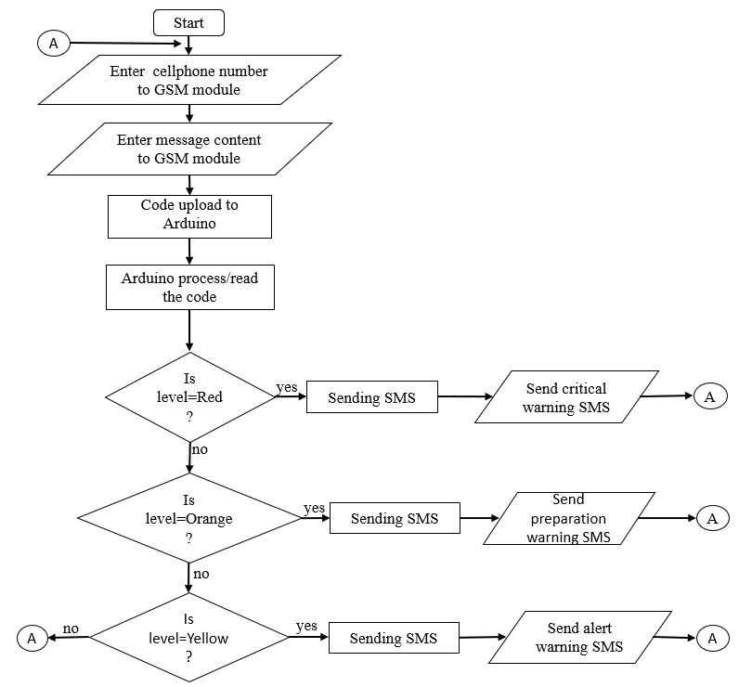

*Figure 4. Flowchart of the System*

Figure 4 shows the process of the system on how it started thru inputting the number of respondents, and the content of the message that will be sent to the registered number. Then the message content will be uploaded and processed to Arduino. When amount of water reach the target level, the system will determine if it is a red warning, Orange Warning or Yellow Warning. If water reaches Red Warning, the system sends critical warning SMS. If the requirements were not met, it will reevaluate the water level. If it reaches Orange Warning, the system sends Preparation warning SMS. If the Yellow Warning was detected, it will send Alert Warning SMS. But if the water stays at a normal level, it will return to initial process.

## 3.5 Systems Design

### 3.5.1 System Development Methodology

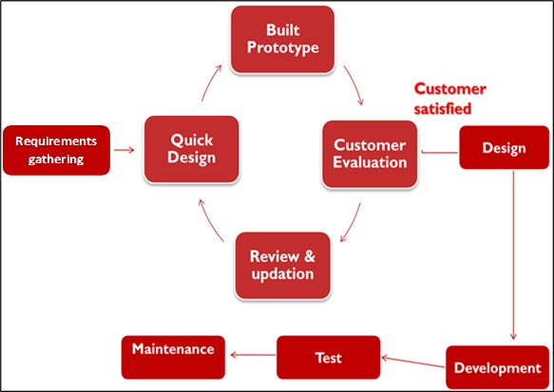

*Figure 5. Prototyping Model*

Researchers utilized a prototyping model in System Development Methodology in which researchers built the system’s prototype, tested it, and reworked it until it met the accepted prototype.

### 3.5.2 Development and Testing

Researchers developed the system by using:

ARDUINO IDE – The open-source Arduino Software (IDE) makes it easy to write code and upload it on the board. This software can be used with any Arduino board.

### 3.5.3 Data Gathering Procedure

Researchers Gathered information requirements about the system and the hardware needed to build the system. Researchers conducted an interview with one person near the area of Annafunan Bridge and asked which barangay is near the bridge and which barangays are always flooded. Also, researchers used printed questionnaires and the questions are based on ISO 25010 evaluation form functional Suitability and Usability.

**3.5.4 Data Analysis**

## Evaluation

The system was evaluated by MDRRMO and the users of the system in some barangays in the municipality of Echague, Isabela. The researchers used a purposive sampling technique in selecting the respondents to the system. Researchers utilized the Likert scale to determine, evaluate, and give feedback to the system. The formula and interpretation of the result (Likert, 1923) are shown in the table below.

Table 3. Likert Scale

|  |  |  |
| --- | --- | --- |
| **Scale** | **Rating** | **Qualitative Rating** |
| **5** | 4.20 – 5.00 | Very Great Extent |
| **4** | 3.40 – 4.19 | Great Extent |
| **3** | 2.60 – 3.39 | Moderate Extent |
| **2** | 1.80 – 2.59 | Little Extent |
| **1** | 1.00 – 1.79 | Very Little Extent |

## Analysis of Data

The mean rating for the different parameters was measured using the following formula given below:

**Rating =** (**VGE*5) + (GE*4) + (ME*3) + (LE*2) + (VLE*1)**

## Total number of Respondent

**Grant mean = TR/SQ** Where:

**Rating =** Total result of Evaluation.

**VGE =** Total number of respondents who answered, “Very Great Extent”.

**GE =** Total number of respondents who answered, “Great Extent”.

**ME =** Total number of respondents who answered, “Moderate Extent”.

**LE =** Total number of respondents who answered, “Little Extent”.

**VLE =** Total number of respondents who answered, “Very Little Extent”.

**TR =** Total number of all Rating.

**SQ =** Number of Sub Question.

### 3.5.5 Population of the Study

Table 4**.** Respondents

|  |  |  |
| --- | --- | --- |
| **Respondent** | **Total number** | **Total** |
| **MDRRMO**  **Administrator** | 2 | 13.33% |
| **Barangay Captains** | 13 | 86.67% |
| **Total** | 15 | 100% |

The population of the study covered: 2 administrators in MDRRMO; and 13 barangay captains, which consists of a total of 15 respondents.

### 3.5.6 Cost-Benefit Analysis Hardware Cost

Table 5. Hardware Cost

|  |  |  |  |
| --- | --- | --- | --- |
| **ITEM** | | **COST** | |
| **Laptop** | | ₱21,000 | |
| **Microcontroller – Arduino Uno** | | ₱400 | |
| **Sensor – Float Switch** | | ₱195 | |
| **Module – SIM900A GSM Module** | | ₱330 | |
| **Battery – 12v Motorcycle Battery** | | ₱300 | |
| **Circuit Board** | | ₱80 | |
| **Wires 150m** | | ₱1,880 | |
| **Switch** | | ₱25 | |
| **Device Container** | | ₱400 | |
| **Smartphone** | | ₱6,990 | |
| **Total Hardware Cost** | | ₱31,530 | |

Table 5 presents the hardware cost needed for the development and deployment of the system.

## Software Cost

Table 6. Software Cost

|  |  |
| --- | --- |
| **ITEM** | **COST** |
| **Windows 10** | ₱3,500 |
| **Arduino Genuino 1.8.16** | ₱0 |
| **Total Software Cost** | ₱3,500 |

The table 6 reveals the software cost needed for the development and deployment of the system.

## Development Cost

Table 7. Development Cost

|  |  |
| --- | --- |
| **ITEM** | **COST** |
| **Programmers Salary** | ₱23,446 |
| **Welder** | ₱1,000 |
| **Electricity** | ₱500 |
| **Total Development Cost** | ₱24,946 |

The table 7 shows the total cost of the project needed for the development of the system.

**3.5.7 Risk Analysis**

## Risk Control

Table 8. Risk Control

|  |  |
| --- | --- |
| **Risk** | **Control** |
| **No connection** | 1. Ensuring the connectivity of the device for the stable signal of the system device. 2. Buying antenna for stronger connectivity for faster signal sharing. |
| **No power** | 1. Regularly check the battery of the device in order to determine if the system device power supply is weak. 2. Check the plug to avoid sudden power off of the device. |
| **Error Code** | 1. Always backup the old code, so if the code is suddenly deleted, there is a source of the previous code. 2. Consult the developer in case there is an error from the code and didn’t know how to debug it. |
| **Unable to run the device** | 1. Check the connection of the device to find out where is the wrong from the system device and run the device. 2. Consult the developer for faster help to run immediately the system device. |
| **Thief** | 1. Regular Inspection of the device and its environment to prevent sudden loss of the device and steal. 2. Installing CCTV near the location of the device so that even if you’re away you’ll see the device neat and working and if someone tries to steal the device, you’ll find it out. |

Table 8 presents the risk control that is used to reduce and eliminate the possible risk.

## 3.6 System Testing Operational Testing

Researchers used this type of system testing to determine and evaluate how the system works prior to the testing period of the system as well as to evaluate its readiness.

## 3.7 Implementation Plan

Table 9. Implementation Plan

|  |  |  |  |
| --- | --- | --- | --- |
| **STRATEGY** | **ACTIVITIES** | **PERSON’S INVOLVED** | **DURATION** |
| **Approval from the office of the**  **MDRRMO at**  **Municipality of Echague,**  **Isabela** | Letter for the  MDRRMO  administrator in the Municipality | MDRRMO  Administrator from the  Municipality | 2 Days |
| **System’s Installation** | Installation of the system and required  software and  hardware, and  the container of the devices | MDRRMO  Administrator from the  Municipality | 7 days |
| **Information Distribution** | Distribution of  Questionnaires | MDRRMO  Administrators and Barangay  Captains | 3 days |

Table 9 shows the implementation performed by the researchers, First step was the securing of approval letter from MDRRMO in Municipality of Echague. Second was the installation or presentation of the device. Last step was the distribution of evaluation form or Questionnaire.

**CHAPTER IV**

**RESULTS AND DISCUSSIONS**

This chapter contains the results of the developed system entitled “IoT Flood Warning Indicator with Arduino based System”. It includes the functionalities and design of the system device. The following are the images of the designed and developed system.

## 4.1 Design and Development of IoT Flood Warning Indicator with Arduino based System

**4.1.1**

**Developed System Device**

*Figure 6. Developed System Device*

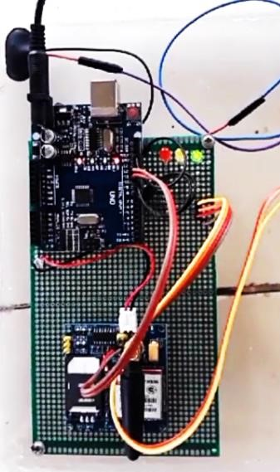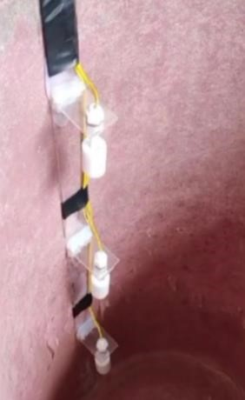

GSM

Sim

Ard

Connecti

on of the

battery to

Power

supply of the

Connection of

sensor and

USB port for

uploading codes

to Arduino

Fl

oa

ter

Figure 6 shows the developed Arduino based system entitled “IoT Flood

Warning Indicator with Arduino based System” that specifically aimed to help the MDRRMO and Barangay Captains to disseminate information when giving a warning to the respondents and take precautionary measures as early as they can when there is an impending flood approaching the area. The system device was designed and developed using hardware devices such as Arduino, GSM Module, and Flouter Sensors, and a C++ programming language where it is used in Arduino compiler software to work the Arduino device.

Although a problem was encountered in terms of detecting the flood when there is a heavy wave and the sensor moved up and down causing multiple sending of messages and giving inaccurate reports, this was addressed by the researchers by building a secure container for the sensor so that the sensor will not be hit by a splash of water or heavy wave.The system met its function in terms of sending warning messages. The SMS warning was sent automatically to the MDRRMO and barangay captains when the level detected a flood. As a result, Hence, this system will be beneficial for future use especially when flood approach the areas. Moreover, the system solved the slow response of rescuing the residents. Thus, the MDRRMO and barangay captains can respond immediately to the residents that need to be rescued when there is flood in their area because the system can easily detect the level of flood and what barangay is affected by the flood.

### 4.1.2 Design of the developed System Device

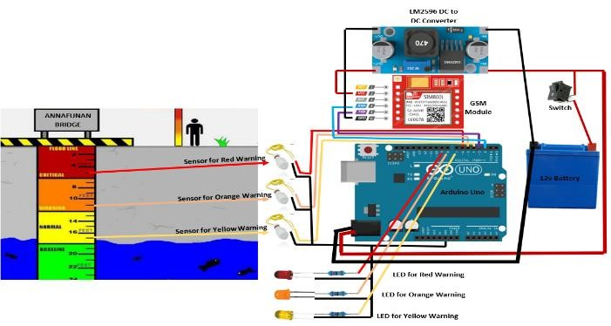

*Figure 7. System Design*

Figure 7 shows the design of the system device were in it can be able to see the connection of the microcontroller into the different parts of the system device the sensors, modules, switch, battery, and led.

## 4.2 Test System Functionalities

### 4.2.1 Short Message Service (SMS) Yellow Warning

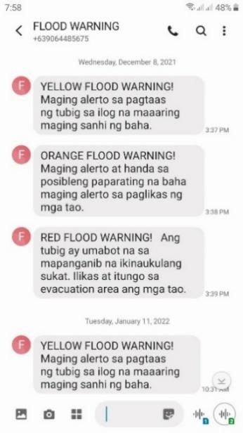

*Figure 8. Yellow Flood Warning SMS Content*

Figure 8 shows the SMS content for the Yellow Flood Warning that informed the MDRRMO and barangay captains about the rising water level at the riverside of Echague. Thus, this helped the residents to be alert for a possible flood.

### 4.2.2 Short Message Service (SMS) Orange Warning

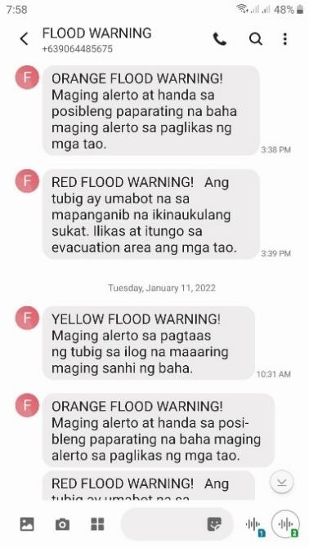

*Figure 9. Orange Flood Warning SMS Content*

Figure 9 shows the SMS content for the Orange Flood Warning that informed the MDRRMO and barangay captains about the rapid rising of flood water level at the riverside of Echague. Thus, this helped the residents to prepare themselves for a possible flood.

### 4.2.3 Short Message Service (SMS) Red Warning

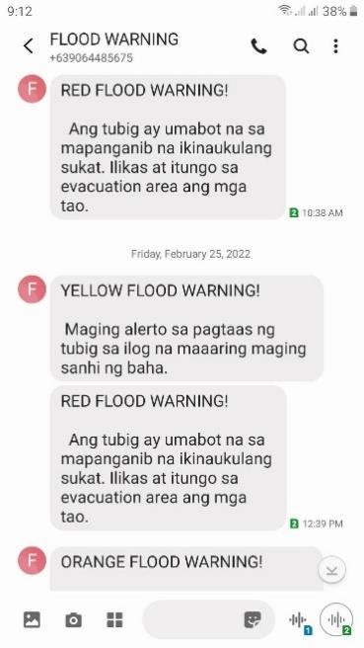

*Figure 10. Red Flood Warning SMS Content*

Figure 10 shows the SMS content for the Red Flood Warning or the risky level of the flood that informed the MDRRMO and barangay captains about the flood that has exceeded the designated normal water level in the riverside of Echague. Thus, this helped the residents to evacuate to the evacuation area.

**4.2.4**

**Flood Warning Indicator Sensors**



Yellow Flood Warning



Red Flood Warning



Orange Flood Warning

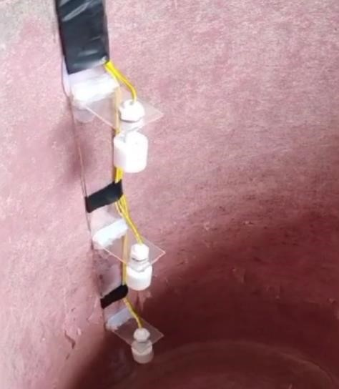

*Figure 11. Flood Warning Indicator Sensors*

By using the Flood Warning Indicator Sensors of the system, the residents were easily warned about the level of the water as the sensor could identify the water level. Wherein, Yellow Warning indicated that residents should be alert for possible impending flood, an Orange Warning indicated to be prepared for a rapid rising of floodwater, and Red Warning indicated that the flood reach its limit level and the residents need to evacuate to a nearby evacuation area.

## 4.3 Evaluation Result (ISO 25010)

The researchers used ISO 25010 evaluation form to assess the system. The system was evaluated by two (2) respondents from MDRRMO and13 respondents from Barangay Captains of the riverside region of the municipality of Echague.

## Functionality Criteria

Table 10. Functionality

|  |  |  |
| --- | --- | --- |
| Questionnaires | Mean Value | Qualitative  Rating |
| **Functional suita** | **bility** |  |
| Device function covers the specified task and objectives. | 4.06 | Great Extent |
| Device function provides correct result with the needed information. | 4.1 | Great Extent |
| Device function facilities the accomplishment of the specified task. | 3.93 | Great Extent |
| **Total** | 4.04 | Great Extent |

Table 10 shows the result of the evaluator on IoT flood warning indicator with Arduino-based system based on its Functionality. Based on the evaluated questionnaires, device function covered the specified task and objective gained 4.06 mean which is equivalent to Great Extent. Device function provided the correct result with the needed information gained 4.1 which is equivalent to Great Extent. And the device function provided facilities on the accomplishment of the specified task that gained 3.93 which is equivalent to Great Extent. The Functional Suitability criteria gained the total grand mean of 4.04 which is equivalent to Great Extent. Based on the result, the device achieved the user’s Requirement in terms of system functionality. This means that the device function met its objective, to detect flood and sends SMS.

## Usability

Table 11. Usability

|  |  |  |
| --- | --- | --- |
| Questionnaires | Mean Value | Qualitative  Rating |
| **Usability** |  |  |
| Device allows user to recognize if it is appropriate for their needs. | 3.8 | Great Extent |
| The device enables the user to learn how to use it with effectiveness, efficiency from risk and satisfaction in a specified context of use. | 4 | Great Extent |
| Device has attributes that make it easy to operate and control. | 3.93 | Great Extent |
| The device can be used by respondents with the widest range of characteristics and capabilities to achieve a specified goal in a specified context. | 3.8 | Great Extent |
| **Total** | 3.88 | Great Extent |

Table 11 shows the result of the evaluators on IoT flood warning indicator with Arduino-based system based on its Usability. Based on the evaluated questionnaires, Device allows users to recognize if it is appropriate for their needs and gained 3.8 which is equivalent to Great Extent. The device enables the user to learn how to use it with effectiveness, efficiency from risk, and satisfaction in a specified context of use gained 4 which is equivalent to Great Extent. Device has attributes that make it easy to operate and control gained 3.93 which is equivalent to Great Extent. The device can be used by respondents with the widest range of characteristics and capabilities to achieve a specified goal in a specified context that gained 3.8 which is equivalent to Great Extent. The Usability criteria gained the total grand mean of 3.88 which is equivalent to a great extent. Based on the result, the device achieved user satisfaction in terms of the system usability. Thus, this means that the device is useful in sending SMS to MDRRMO and Barangay captains when there is a flood. Table 12. Evaluation Summary

|  |  |  |
| --- | --- | --- |
| Questionnaires | Mean Value | Qualitative  Rating |
| Functional Suitability | 4.04 | Great Extent |
| Usability | 3.88 | Great Extent |
| **Total** | 3.96 | Great Extent |

Table 12 shows the summary of the results from the system device’s functional suitability and usability Evaluation. The total summary of the evaluated questionnaires gained 3.96 which is equivalent to Great Extent. That indicates that the system performed its functionalities and met its objective.

**CHAPTER V**

**SUMMARY, CONCLUSIONS, AND RECOMMENDATIONS**

This chapter discusses the summary of the project where all the activities in the development and different tools used are described. This also includes conclusions where all main functionalities of the system provide the appropriate solution for the problems encountered by the organization. The researchers also stated recommendations for the future enhancement of the system.

## 5.1 Summary

The developed system device for the MDDRMO named IoT Flood Warning Indicator with Arduino based System aimed to solve the problem where MDRRMO units and Barangay Captains find it difficult to know if there is an impending flood in neighboring barangays near the river. This is one of the reasons why MDRRMO always failed to disseminate information and reminders in advance to the respondents. They did not know if there was an impending flood. Also, there was no source of contact information from the rescuer.

During the conduct of the study, the researchers identified the problems encountered by the organization. The researchers proposed a system that can aid the problems encountered, entitled IoT Flood Warning Indicator with Arduino-based System. It is a system device that is capable of Sending a Short Message Service (SMS) about the Flood Warning. The category of the SMS that was sent by the device when it detects a flood falls under Yellow Warning, Orange Warning, and Red Warning. Yellow Warning warns the respondents about the impending flood. Orange Warning warns the respondents to prepare to evacuate because the risk level is approaching. Red Warning warns the respondents to evacuate as much as possible and head to the evacuation site.

The system device has a GSM module to send a Text message to the MDRRMO and some Barangay Captains for a quick warning to the respondents instead the MDRRMO will go to the site to find out the look and level of the water before giving a warning to the respondents to evacuate.

The researchers used Prototype Development method in developing the project faster. The researchers also used the following tools and technologies in developing the IoT Flood Warning Indicator with Arduino based System: for the system, device researchers used the following hardware devices: Arduino Uno, GSM Module, Floater, Battery, and for the software, the researchers used the Arduino IDE for the development of the code.

The use of the different logical diagrams such as the fishbone diagram helped the researchers identify the cause and effect of the identified problems, the functional decomposition diagram, and the flow chart diagram to describe the sequential order of events from the system device. The system was evaluated in terms of the level of usability and the evaluators rated it as 3.88 which is equivalent to “Great Extent” and for the level of functionality, the evaluators rated it as 4.04 which is equivalent to “Great Extent” with the use of the ISO 25010. The overall result of the system’s evaluation regarding the system compliance to the ISO 205010 standard evaluated by the MDRRMO Admins and different Barangay Captains in Echague, Isabela, the evaluators rated the system as 3.96 which is equivalent to “Great Extent”. It implies that the overall usefulness of the system is a great extent upon, that is highly functional and usable to the end-users.

## 5.2 Conclusions

After the successful development of the system “IoT Flood Warning Indicator with Arduino based System”, the researchers conclude that:

1. The used hardware devices such as Arduino Uno, SIM900A GSM module, and Floater Sensors is a good technology to develop a Flood Warning Indicator system that helps MDRRMO and Barangay Captains to lessen the time in providing early flood warning to the residents of Echague Isabela.
2. The system made it faster and easier to see the level of the water from the river and see if there is an impending flood approaching the areas that were always flooded. Using sensors, it helped the MDRRMO and Barangay Captain identify water level without risking lives. The MDRRMO and Barangay Captains were capable now to provide reminder to the residents in their leading areas.
3. The result of the system evaluation using ISO 25010 in terms of usability and functionality evaluated by the MDRRMO Admin and Barangay Captains resulted in Great Extent. This implies that the developed system is very useful in terms of giving an early flood warning from the MDRRMO and Barangay Captains from the different barangay in the riverside region of Echague, Isabela.

## 5.2 Recommendations

Researchers recommend the following for the improvement of the capstone project:

1. Develop a Simple Interface of the System Device (Web-based Application).This can help the Residents be aware of the water level quickly and if they need to evacuate. Also, Residents can see the rescuers contact information using the Web page.
2. Flood Hazard Mapping. This can make it easier for rescuers to find out the areas and help the residents affected by flood.
3. Resident Profiling System for faster. By filling this out, MDRRMO and rescuers can easily locate the missing persons. This can help them lessen the workload and save time and lives.
4. Hardware upgrade. Use solar panel in order to have a lifetime power supply for the battery.

**BIBLIOGRAPHY**

**REFERENCES**

Jadhav, A., Jadhav, H., & Jalkote, S. (2020). Flood Detection and Alert System Based on IoT. A journal of IRJMETS, pp. 1084-1090

Sayyad et al. (2020). IOT Based Early Flood Detection and Avoidance. IRE Journals, pp. 50-55

Rismayana, A. H., Sugianto, C.S., & Budiyanto, I. B. (2018). Prototyping of Flooding Early Warning System using Internet of Things Technology and Social Media. pp 1-5

Arshad, B. et al. (2019). Computer Vision and IoT Based Sensor in Flood Monitoring and Mapping: A Systematic Review. MDPI Journals, pp 1-28

Subramaniam, S. K. et al. (2010). Flood Level Indicator and Risk Warning

System for Remote Location Monitoring using Flood Observation System. pp 153-163

Souza A. S., et al. (2017). A Flood Warning System to Critical Region. pp 1104-

1109

Mohd Sabre, M. S., Abdullah S.S., Faruq, A. (2019). Flood Warning and Monitoring System Utilizing Internot of Things Technology. pp 287-296

Zahir, S. B. et al. (2019). Smart IoT Flood Monitoring System. journal of physics: Conference Series, pp 1-7

Labo, J. J., Floresca, E. E., & Gracilla L. E. (2016). Development of Flood

Warning System. Journal of Engineering Research and Application, pp 57-64 Sheshu, E. D., Manjunath, N., Karthik, S., & Akash, U. (2018, August).

Implementation of flood warning system using iot. In *2018 Second International Conference on Green Computing and Internet of Things (ICGCIoT)* (pp. 445-448). IEEE.

Arshad, B., Ogie, R., Barthelemy, J., Pradhan, B., Verstaevel, N., & Perez, P. (2019). Computer vision and IoT-based sensors in flood monitoring and mapping: A systematic review. *Sensors*, *19*(22), 5012.

Ghapar, A. A., Yussof, S., & Bakar, A. A. (2018). Internet of Things (IoT) architecture for flood data management. *International journal of future generation communication and networking*, *11*(1), 55-62.

Shah, W. M., Arif, F., Shahrin, A. A., & Hassan, A. (2018). The implementation of an IoT-based flood alert system. *International Journal of Advanced Computer Science and Applications*, *9*(11), 620-623.

Babu, V., & Rajan, V. (2019, July). Flood and earthquake detection and rescue using IoT technology. In *2019 International Conference on Communication and Electronics Systems (ICCES)* (pp. 1256-1260). IEEE.

Satria, D., Yana, S., Munadi, R., & Syahreza, S. (2018). Design of information monitoring system flood based internet of things (IoT). In *Proceedings of MICoMS 2017*. Emerald Publishing Limited.

Jayashree, S., Sarika, S., Solai, A. L., & Prathibha, S. (2017, February). A novel approach for early flood warning using android and IoT. In *2017 2nd International Conference on Computing and Communications Technologies (ICCCT)* (pp. 339-343). IEEE.

Patil, S., Pisal, J., Patil, A., Ingavale, S., Ayarekar, P., & Mulla, P. S. (2019). A real time solution to flood monitoring system using IoT and wireless sensor networks. *Irjet*, *6*(2), 1807-1811.

Diriyana, A., Darusalam, U., & Natasha, N. D. (2019). Water Level Monitoring and Flood Early Warning Using Microcontroller With IoT Based Ultrasonic Sensor. *Jurnal Teknik Informatika CIT Medicom*, *11*(1), 22-28.

Simatupang, J. W., & Naufal, F. (2019). Flood Early Warning Detection System Prototype Based on IoT Network. *Internetworking Indonesia Journal*, *11*(1), 17-22. Anbarasan, M., Muthu, B., Sivaparthipan, C. B., Sundarasekar, R., Kadry, S., Krishnamoorthy, S., & Dasel, A. A. (2020). Detection of flood disaster system based on IoT, big data and convolutional deep neural network. *Computer Communications*, *150*, 150-157.

Abdullahi, S. I., Habaebi, M. H., & Abd Malik, N. (2019). Intelligent flood disaster warning on the fly: developing IoT-based management platform and using 2class neural network to predict flood status. *Bulletin of Electrical Engineering and Informatics*, *8*(2), 706-717.

Zahir, S. B., Ehkan, P., Sabapathy, T., Jusoh, M., Osman, M. N., Yasin, M. N., ... & Jamaludin, R. (2019, December). Smart IoT flood monitoring system. In *journal of physics: conference series* (Vol. 1339, No. 1, p. 012043). IOP Publishing.

Subashini, M. J., Sudarmani, R., Gobika, S., & Varshini, R. (2021, February). Development of Smart Flood Monitoring and Early Warning System using Weather

Forecasting Data and Wireless Sensor Networks-A Review. In *2021 Third International Conference on Intelligent Communication Technologies and Virtual Mobile Networks (ICICV)* (pp. 132-135). IEEE.

Kumar, N., Goyal, P., Kapil, G., Agrawal, A., & Khan, R. A. (2020). Flood risk finder for IoT based mechanism using fuzzy logic. *Materials Today: Proceedings*.

Esposito, M., Palma, L., Belli, A., Sabbatini, L., & Pierleoni, P. (2022). Recent Advances in Internet of Things Solutions for Early Warning Systems: A Review. *Sensors*, *22*(6), 2124.

Sood, S. K., Sandhu, R., Singla, K., & Chang, V. (2018). IoT, big data and HPC based smart flood management framework. *Sustainable Computing: Informatics and Systems*, *20*, 102-117.

Hadi, M. I., Yakub, F., Fakhrurradzi, A., Hui, C. X., Najiha, A., Fakharulrazi, N. A., ... & Azizan, A. (2020, June). Designing early warning flood detection and monitoring system via IoT. In *IOP Conference Series: Earth and Environmental Science* (Vol. 479, No. 1, p. 012016). IOP Publishing.

Napiah, M. N., Idris, M. Y. I., Ahmedy, I., & Ngadi, M. A. (2017, May). Flood alerts system with android application. In *2017 6th ICT international student project conference (ICT-ISPC)* (pp. 1-4). IEEE.

Samikwa, E., Voigt, T., & Eriksson, J. (2020, November). Flood Prediction Using IoT and Artificial Neural Networks with Edge Computing. In *2020 International*

*Conferences on Internet of Things (iThings) and IEEE Green Computing and Communications (GreenCom) and IEEE Cyber, Physical and Social Computing*

*(CPSCom) and IEEE Smart Data (SmartData) and IEEE Congress on Cybermatics (Cybermatics)* (pp. 234-240). IEEE.

Roy, M., Pradhan, P., George, J., & Pradhan, N. (2020). Flood Detection and Water Monitoring System Using IOT. *International Journal Of Engineering And Computer Science*, *9*(07), 25113-25115.

## APPENDICES

**Appendix A Relevant**

**Source Code**

**Indicates Flood Warning** void loop(){ button_State = digitalRead(button1); if (button_State != lastbuttonstate1)

{ lastbuttonstate1 = button_State; digitalWrite(ledPin1, HIGH); Serial.println("Float Switch 1 ON"); delay(200);

SendSMS1();

} else { digitalWrite(ledPin1, LOW);

} if (sim800l.available())

{

Serial.write(sim800l.read());

}

button_State = digitalRead(button2); if (button_State != lastbuttonstate2)

{ lastbuttonstate2 = button_State; digitalWrite(ledPin2, HIGH); Serial.println("Float Switch 2 ON"); delay(200);

SendSMS2();

} else { digitalWrite(ledPin2, LOW);

} if (sim800l.available())

{

Serial.write(sim800l.read());

}

button_State = digitalRead(button3); if (button_State != lastbuttonstate3)

{ lastbuttonstate3 = button_State; digitalWrite(ledPin3, HIGH); Serial.println("Float Switch 3 ON"); delay(200);

SendSMS3();

} else

{

digitalWrite(ledPin3, LOW);

} if (sim800l.available())

{

Serial.write(sim800l.read());

}

}

### Flood Warning SMS Content void SendSMS1()

{

Serial.println("Sending SMS..."); sim800l.print("AT+CMGF=1\r"); delay(1000); sim800l.print("AT+CMGS=\"+639614116441\"\r"); delay(500);

sim800l.print("YELLOW FLOOD WARNING! Maging Alerto at handa sa posibleng paparating na baha sa inyong barnggay maging alerto sa pag likas. Maaring tawagan ang mga kinauukulan sa karagdagang impormasyan.NDRRMC emergency hotline: 0917 626 2352 o 0919 991

7115"); delay(500); sim800l.print((char)26); delay(500); sim800l.println(); Serial.println("Text Sent."); delay(500);

}

void SendSMS2()

{

Serial.println("Sending SMS..."); sim800l.print("AT+CMGF=1\r"); delay(1000); sim800l.print("AT+CMGS=\"+639614116441\"\r"); delay(500);

sim800l.print("ORANGE FLOOD WARNING! Maging Alerto at handa sa maaring mabilis na pag taas ng tubig sa ilog na maaring mag sanhi ng baha sa inyong lugar. Maaring tawagan ang mga kinauukulan sa karagdagang impormasyan. NDRRMC emergency hotline: 0917 626 2352 o 0919 991 7115"); delay(500); sim800l.print((char)26); delay(500); sim800l.println(); Serial.println("Text Sent."); delay(500);

}

void SendSMS3()

{

Serial.println("Sending SMS..."); sim800l.print("AT+CMGF=1\r"); delay(1000);

sim800l.print("AT+CMGS=\"+639614116441\"\r"); //Your phone number

delay(500);

sim800l.print("RED FLOOD WARNING! Ang tubig ay umabot sa sa lagpas anim na metro mula sa batayang antas ng tubig. Pag likas sa inyong lugar ay mahigpit ng pinapatupad maaring mag tungo sa pinaka mataas na lugar sa inyong baranggay. Maaring tawagan ang mga kinauukulan sa karagdagang impormasyan. NDRRMC emergency hotline: 0917 626 2352 o 0919 991 7115"); delay(500); sim800l.print((char)26); delay(500); sim800l.println(); Serial.println("Text Sent."); delay(500);}

**Appendix B**

**Sample**

**Input/Output/Report**

### Sensor Detects Flood



1. **Input:** The water from the river reaches the Yellow Warning Sensor. The microcontroller detects a signal came from the sensor.
2. **Output:** The Yellow Warning SMS has been Sent into the Smartphone of the End User.



1. **Input:** The water from the river reaches the Yellow Warning Sensor. The microcontroller detects a signal came from the sensor.
2. **Output:** The Yellow Warning SMS has been Sent into the Smartphone of the End User.



1. **Input:** The water from the river reaches the Yellow Warning Sensor. The microcontroller detects a signal came from the sensor.
2. **Output:** The Yellow Warning SMS has been Sent into the Smartphone of the End User.

### Appendix C

**User’s guidelines**

#### Insert new phone number into the device – Yellow Warning

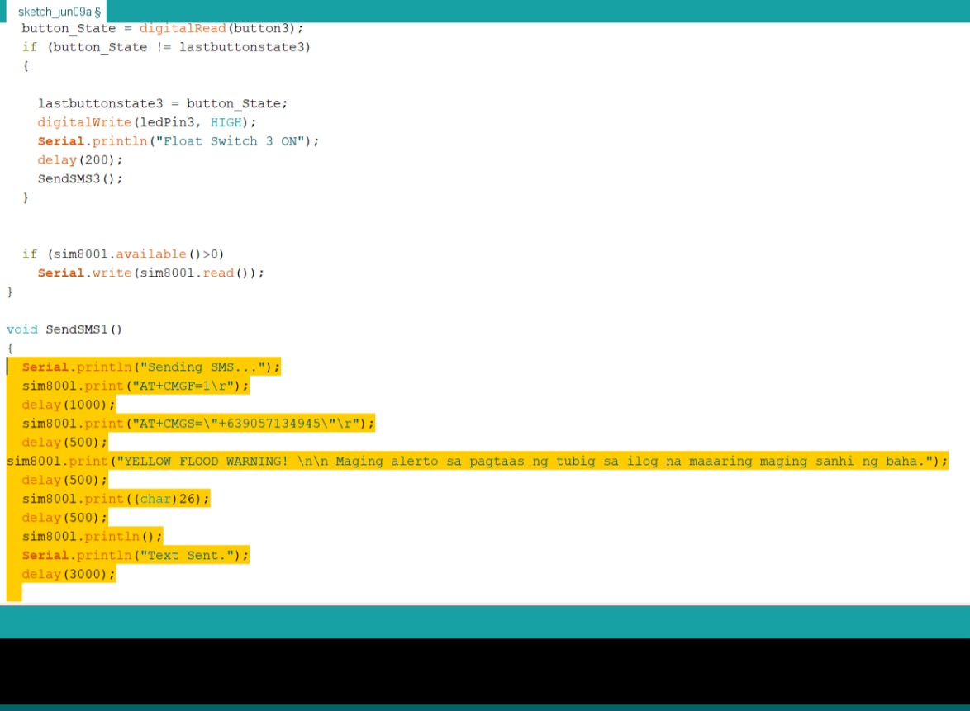

1. Highlight all the content from the Yellow Flood Warning SMS Content then press from the keyboard CTRL+C to copy the highlighted content from the code.

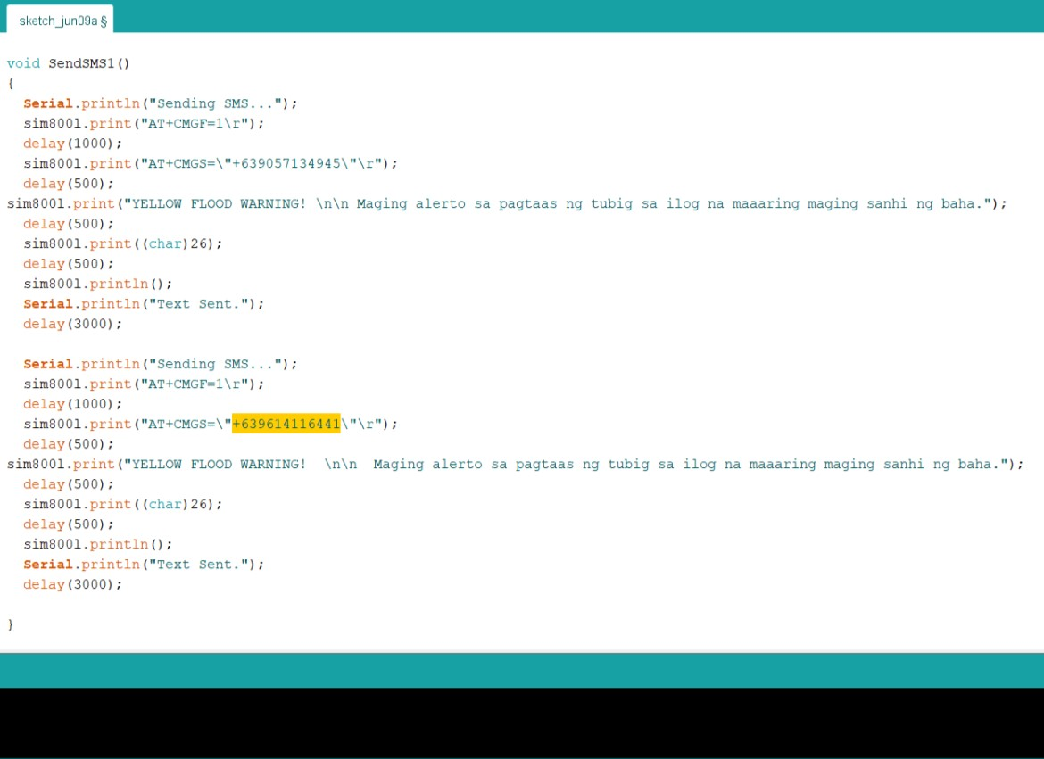

1. Click at the bottom of the copied code then press CTRL+V to paste the code. Then highlight the Phone number from the copied Code then change it with a new phone number came from another user of the system device.

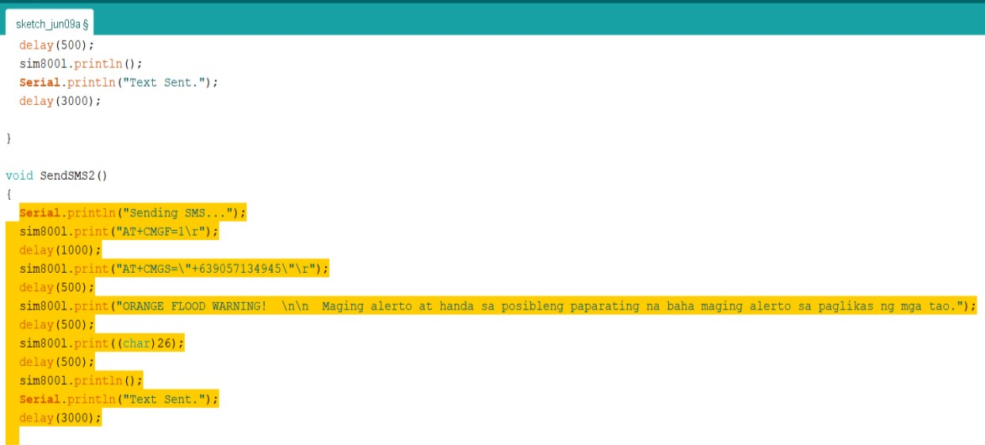

1. . Highlight all the content from the Orange Flood Warning SMS Content then press from the keyboard CTRL+C to copy the highlighted content from the code.

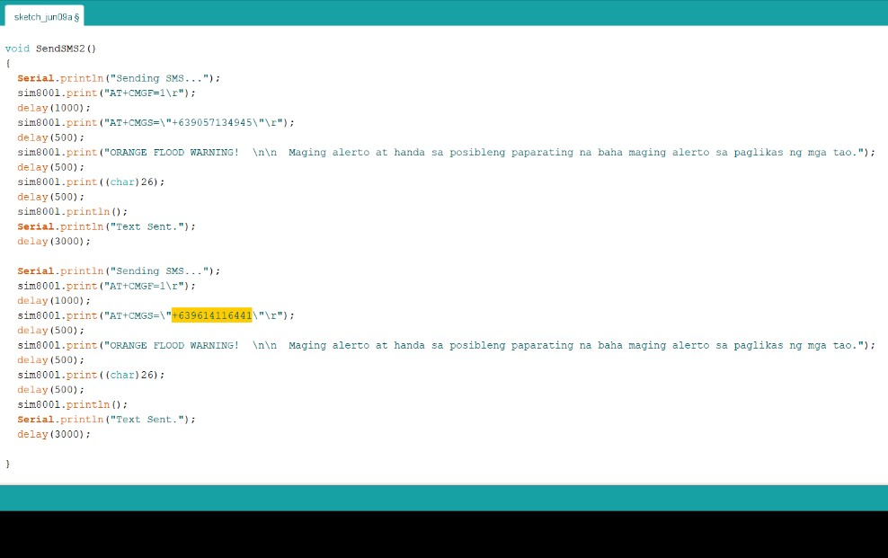

1. Click at the bottom of the copied code then press CTRL+V to paste the code. Then highlight the Phone number from the copied Code then change it with a new phone number came from another user of the system device.

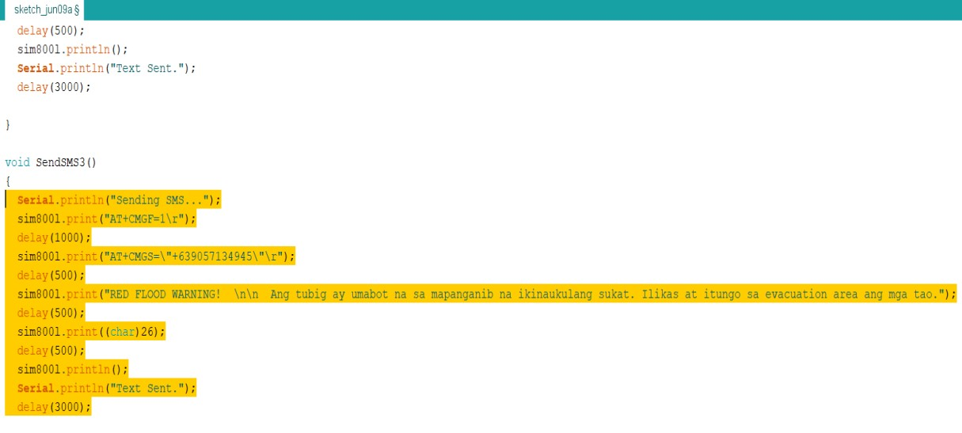

1. . Highlight all the content from the Red Flood Warning SMS Content then press from the keyboard CTRL+C to copy the highlighted content from the code.

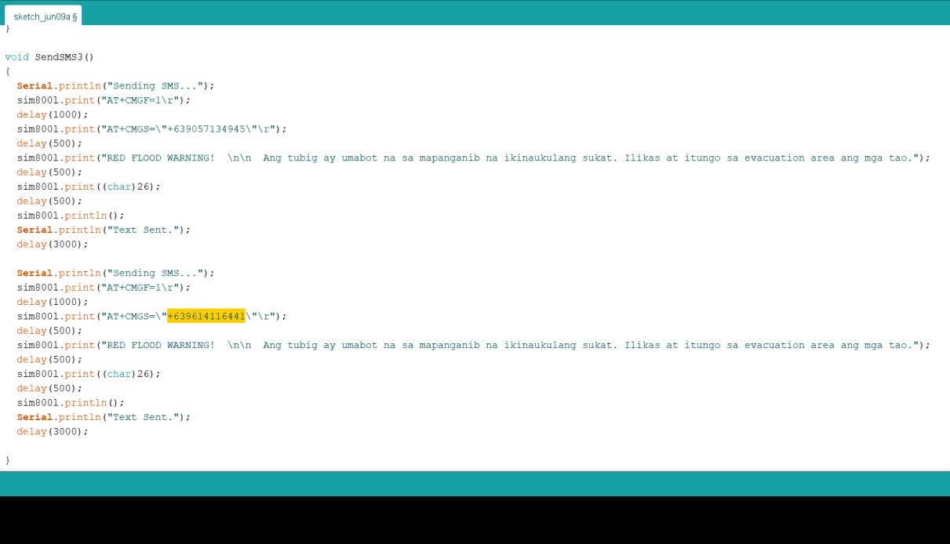

1. Click at the bottom of the copied code then press CTRL+V to paste the code. Then highlight the Phone number from the copied Code then change it with a new phone number came from another user of the system device.

**Turn on the system device**

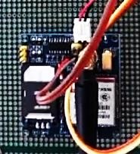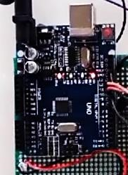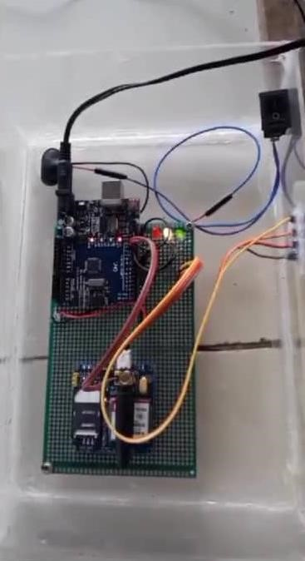

**1**

GSM

ARDUI

* 1. Insert the charger or the 12v battery to the device.
  2. Switch: to Power on/off the System Device.

**Appendix D**

**Other Relevant**

### Documents

#### Certificate of Implementation

**PERMISSION TO START**

**(SYSTEM IMPLEMENTATION)**

|  |
| --- |
| **RESEARCHERS** |
| 1. Rowell U. Taguba 2. Janeth B. Simangan 3. Robinson F. Linato jr |

|  |
| --- |
| **TITLE OF CAPSTONE PROJECT** |
| **Iot Flood Warning Indicator with Arduino Based System** |

|  |  |  |
| --- | --- | --- |
| DATE TO START |  | March 28, 2022 |
| TENTATIVE DATE  TERMINATE | TO | April 4, 2022 |
| DURATION OF | PROJECT |  |
| IMPLEMENTATION |  | 7 days |
| NAME OF AGENCY |  | MDDRMO Risk Reduction Management  Echague Evacuation Center |
| AGENCY ADDRESS |  | San Fabian, Echague, Isabela |

**RECOMMENDING APPROVAL:**

|  |  |  |  |
| --- | --- | --- | --- |
|  | |  | |
| ROMERO DANTE C. SALUM, MIT  (Signature of the Project Adviser over printed name) | | DARIOS B. ALADO, DIT  (Signature of Panel Chair over printed name) | |
| Date |  | Date |  |

**APPROVED:**

|  |  |  |  |
| --- | --- | --- | --- |
|  | |  | |
| RENALYN G. TECSON, MIT  (Signature of the Program Chair over printed name) | | CHRISTINE CHARMAINE G. SAN JOSE,  DIT  (Signature of Dean over printed name) | |
| Date |  | Date |  |

#### Certificate of Appreciation

**Appendix E**

**Grammarian Certificate**

### Appendix F Gallery

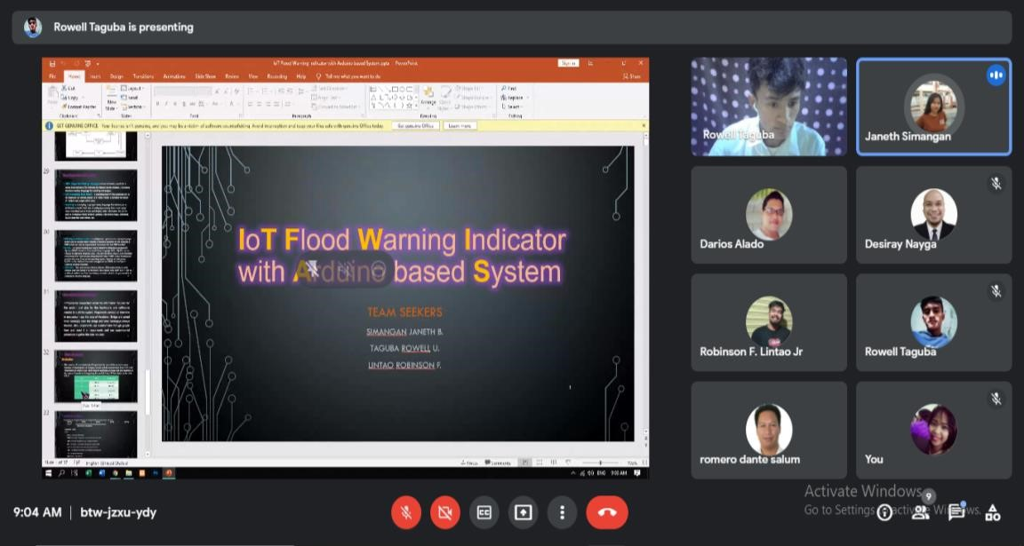

This Screen Shot was taken during our Proposal Defense.

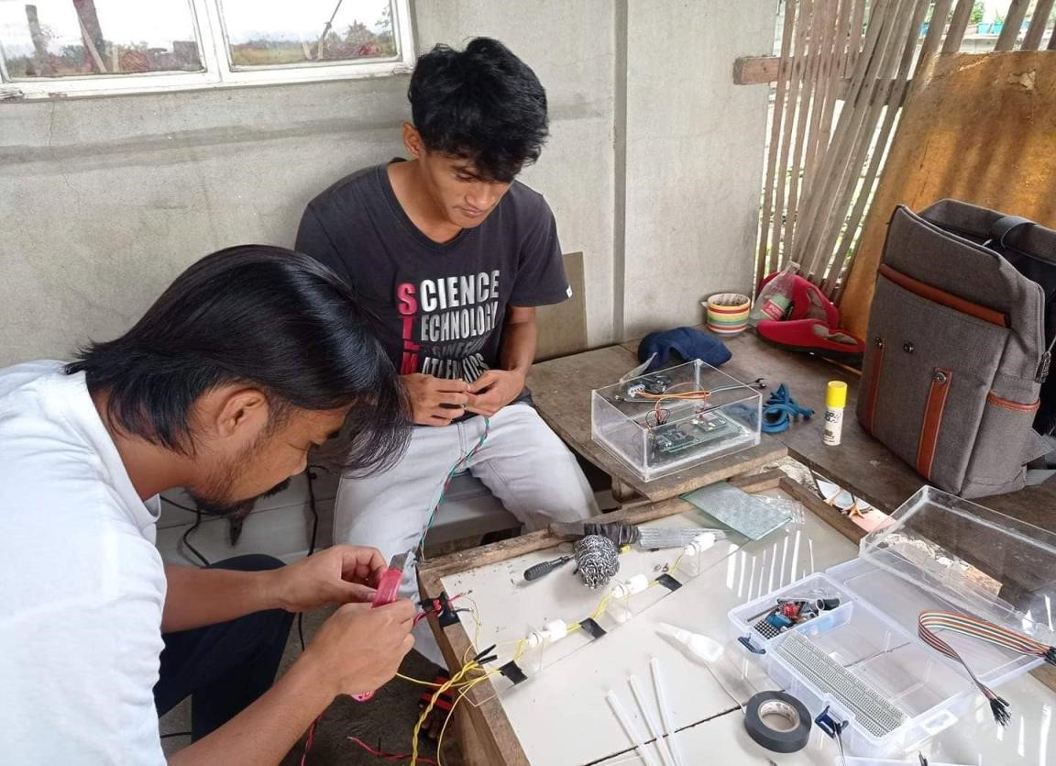

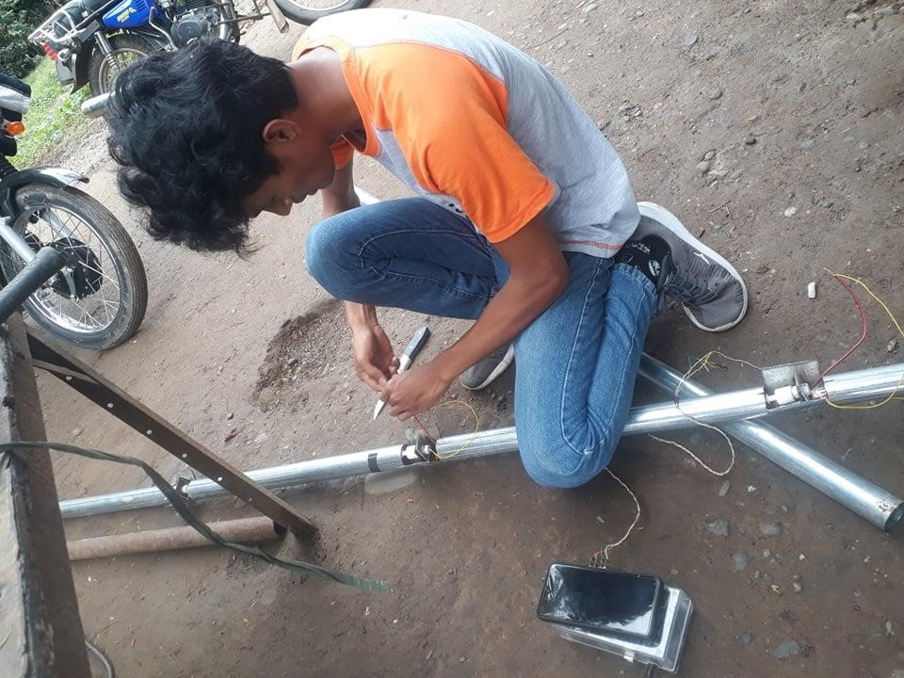

This Photo was taken during the Construction and testing of the system Device.

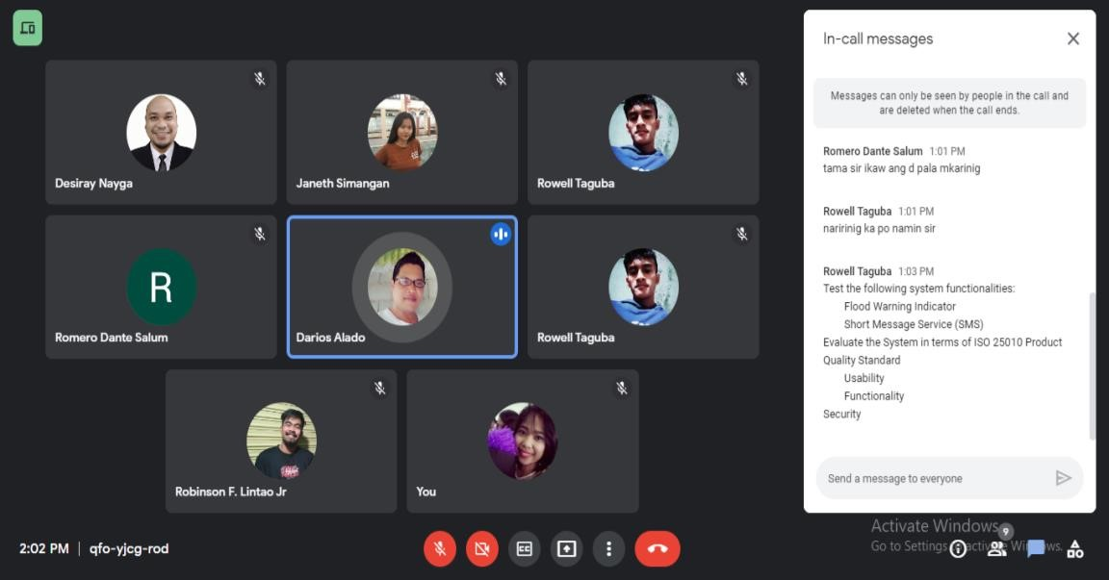

This Screen Shot was taken during our System Defense.

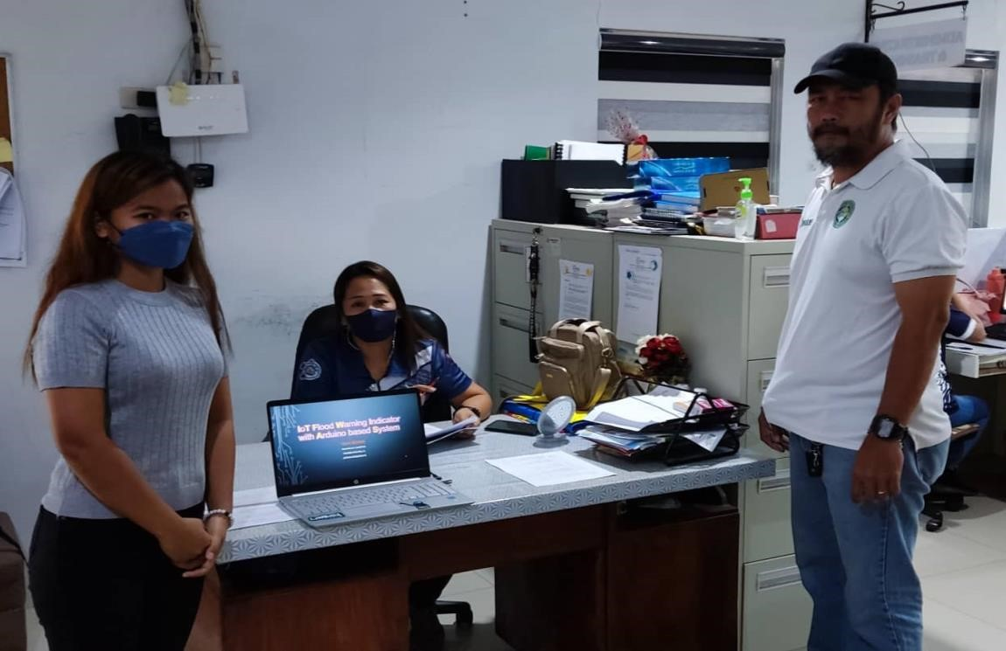

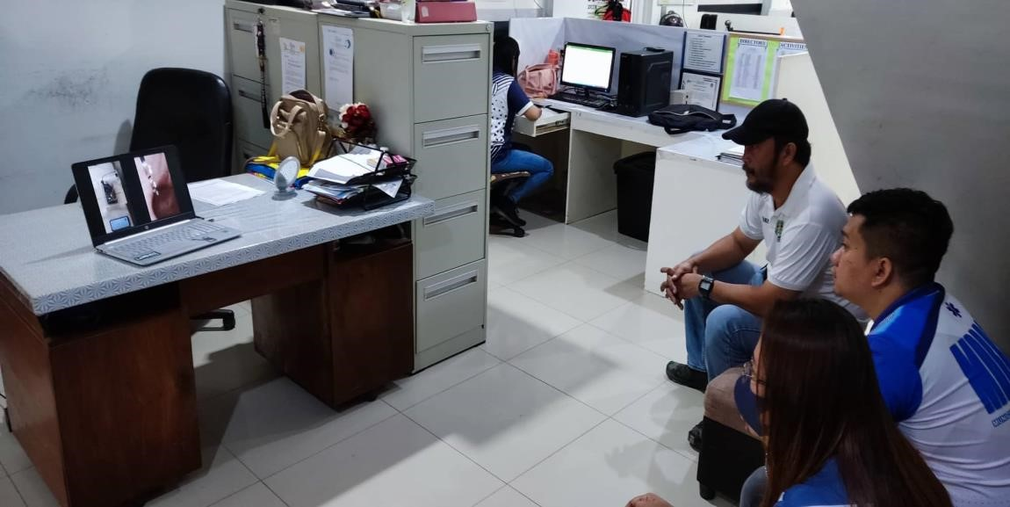

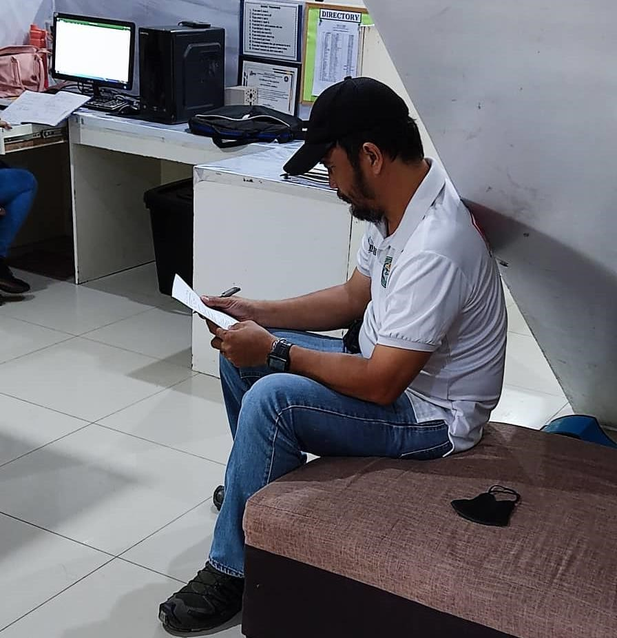

This photo was taken during the Presentation of the system and evaluation at MDRRMO

Echague Isabela

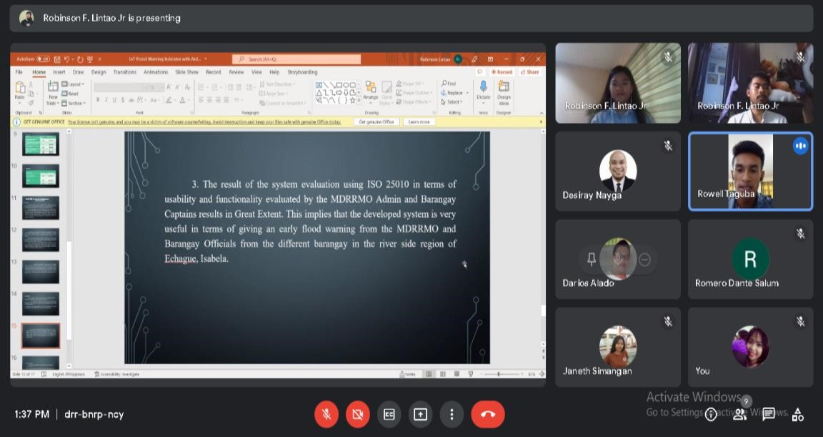

This Screen Shot was taken during our Manuscript Defense.

.

### Appendix G

**Curriculum Vitae**

**Curriculum Vitae**

**Name:**

**Rowell U. Taguba**

Contact:

09614116441

Email:

tagubarowell37@gmail.com

s

Personal Information

Nationality:

Filipino



Civil Status: Single

Date of Birth: May 08, 2000

Place of Birth: Minanga Proper, Angadanan, Isabela Religion: Catholic

Mother’s Name: Merely U. Taguba

Occupation: Housewife

Father’s Name: Ricardo P. Taguba

Occupation: Farmer

Educational Background

University: Isabela State University

Course: Bachelor of Science in Information Technology

Address: San Fabian, Echague, ISabela

High School

Junior High: Angadanan National High School

Address: Centro 1, Angadanan, Isabela

Senior High: Angadanan National High School

Strand: Science, Technology, Engineering and Mathematics

Address: Centro 1, Angadanan, Isabela

Elementary: Lomboy Intergated School

Address: Lomboy, Angadanan, Isabela

**Curriculum Vitae**

**Name:**

**Janeth B. Simangan**

Contact:

090644856756

Email:

jajasimangan2@gmail.com

Personal Information

Nationality:

Filipino



Civil Status: Single

Date of Birth: July 02, 1999

Place of Birth: Maligaya, Echague, Isabela Religion: Born Again

Mother’s Name: Rosie B. Simangan

Occupation: Housewife

Father’s Name: Orlando G. Simangan

Occupation: Carpenter

Educational Background

University: Isabela State University

Course: Bachelor of Science in Information System

Address: San Fabian, Echague, Isabela



High School

Junior High: Don Mariano Marcos National High School

Address: Ipil, Echague, Isabela

Senior High: Don Mariano Marcos National High School

Strand: Technical Vocational Livelihood – Information Communication

Technology

Address: Ipil, Echague, Isabela

Elementary: Maligaya Elementary School

Address: Maligaya, Echague, Isabela

**Curriculum Vitae**

#### Name: Robinson F. Lintao Jr

Contact: 09567689217

Email: robinsonlintao018@gmail.com

Personal Information

Nationality: Filipino

Civil Status: Single

Date of Birth: March 18, 2000

Place of Birth: Mabini, Gamu, Isabela Religion: Iglesia Ni Cristo

Mother’s Name: Maribel F. Lintao Occupation: OFW

Father’s Name: Robinson J. Lintao Sr.

Occupation: Farmer

Educational Background

University: Isabela State University

Course: Bachelor of Science in Information Technology

Address: San Fabian, Echague, Isabela

High School

Junior High: Mabini National High School

Address: Mabini, Gamu, Isabela

Senior High: Mabini National High School

Strand: General Academic Strand

Address: Mabini, Gamu, Isabela

Elementary: Mabini Elementary School

Address: Mabini, Gamu, School

#### Glossary

**Arduino –** is a computer hardware and software manufacturer and user community that designs and manufactures kits for building interactive objects that interact with the physical world. The company mainly produces undersized and inexpensive singleboard computers, perfect for hobbyist projects where a small, programmable computer is required.

**Arduino Uno –** the Arduino uno is categorized as a microcontroller that uses the atmega328 as a controller in it. The Arduino uno board is used for an electronics project and mostly preferred by the beginners. The Arduino uno board I type of Arduino board only. The Arduino board is the most used board of all Arduino boards. The board contains 14 digital input/ output pins in which 6 are analog input pin, one power jack, USB connector, one reset button, ICSP header, and other components. All these components are attached in the Arduino uno board to make it functioning and can be used in the project. The board is charged by USB port or can be directly charged by the dc supply to the board (Pooja Gupta, 2022).

**Data –** is different types of information that usually is formatted in a particular manner.

All the software is divided into two major categories, and those are programs and data. Programs are the collection made of instructions that are used to manipulate data. **Fishbone Diagram –** also called a cause-and-effect diagram or Ishikawa diagram, is visualization tool for categorizing the potential causes of a problem in order to identify its root causes (Margaret Rouse, 2005).

**Flood Warning –** is closely linked to the task of [flood forecasting.](https://en.wikipedia.org/wiki/Flood_forecasting) The distinction between the two is that the outcome of flood forecasting is a set of forecast time-profiles of channel flows or river levels at various locations, while "flood warning" is the task of making use of these forecasts to make decisions about whether warnings of floods should be issued to the public or whether previous warnings should be rescinded or retracted.

**Flow Chart –** is a diagram that depicts a process, system or computer algorithm. They are widely used in multiple fields to document, study, plan, improve and communicate often complex processes in clear, easy-to-understand diagrams.

**Floater Sensor –** A float sensor, sometimes called a float switch, is a device that is used to sense the level of a fluid. It acts as a mechanical switch. There is a float ring surrounding the sensor. When the float is at the bottom, the switch is open. When water level rises, it pushes the float upwards and the switch closes.

**Functionality –** "A set of attributes that bear on the existence of a set of functions and their specified properties. The functions are those that satisfy stated or implied need. **Functional Decomposition Diagram –** The functional decomposition is a technique to break a logic function with many variables into several functions with fewer variables. The functions with fewer variables can be designed independently, and are relatively easier to design (T. Sasao, 1993)

**Gantt Chart** – a type of chart that illustrates a project schedule (Karol Adamiecki & Henry Gantt, 1890).

**GSM Module –** is used to establish communication between a computer and GSM-GPRS system. Global System for Mobile communication (GSM) is an architecture used for mobile communication in most of the countries. GSM module consists of a GSM modem assembled together with power supply circuit and communication interfaces (like RS-232, USB, etc) for computer. GSM MODEM is a class of wireless MODEM devices that are designed for communication of a computer with the GSM network. It requires a SIM (Subscriber Identity Module) card just like mobile phones to activate communication with the network. Also, it has IMEI (International Mobile Equipment Identity) number similar to mobile phones for the identification. A GSM MODEM can perform the following functionalities: receive, send or delete SMS messages in a SIM, read, add, search phonebook entries of the SIM, and make, receive, or reject a voice call (Ashutosh Bhatt, 2022).

**Hardware –** is best described as any physical component of a computer system containing a [circuit board,](https://www.computerhope.com/jargon/p/pcb.htm) [ICs,](https://www.computerhope.com/jargon/i/ic.htm) or other electronics.

**Input Process Output –** A graphical representation of all the factors that make up a process. An input-process-output diagram includes all of the materials and information required for the process, details of the process itself, and descriptions of all products and by-products resulting from the process (Jeffrey G., 2014).

**Internet of Things –** is the concept of connecting any device (so long as it has an on/off switch) to the Internet and to other connected devices. The IoT is a giant network of connected things and people – all of which collect and share data about the way they are used and about the environment around them (Jen Clark, 2016).

**ISO 25010 –** is the cornerstone of a product quality evaluation system. The quality model determines which quality characteristics will be taken into account when evaluating the properties of a [software product.](https://12monthsloansbadcredit.com/blog/impact-digitalization-financial-services/) It is the degree to which the system satisfies the stated and implied needs of its various stakeholders, and thus provides value. Those stakeholders' needs (functionality, performance, security, maintainability, etc.) are precisely what is represented in the quality model, which categorizes the product quality into characteristics and sub-characteristics (iso25000, 2022).

**Prototyping Model –** **is** a process model which is used to develop software’s. The main purpose of the prototyping model is to **satisfy the customer’s need**. To acquire this, developers implement the prototype and present it to the customer for evaluation. After evaluation customer suggests the modifications in the prototype. The suggested modifications are then implemented in the prototype and again it is presented to the customer for evaluation (Neha T, 2020).

**Short Message Service –** is the text messaging service on most mobile phones and other mobile devices. SMS is based on standardized communication protocols to send text messages from device to device. The standardized nature of SMS is the primary reason that it’s the most ubiquitous text messaging service.

**Software –** is a collection of instructions that enable the user to interact with a computer, its hardware, or perform tasks.

**Usability –** "A set of attributes that bear on the effort needed for use, and on the individual assessment of such use, by a stated or implied set of users."